Geological and economic potential of white hydrogen as a renewable resource
Source, reservoir and availability of natural hydrogen

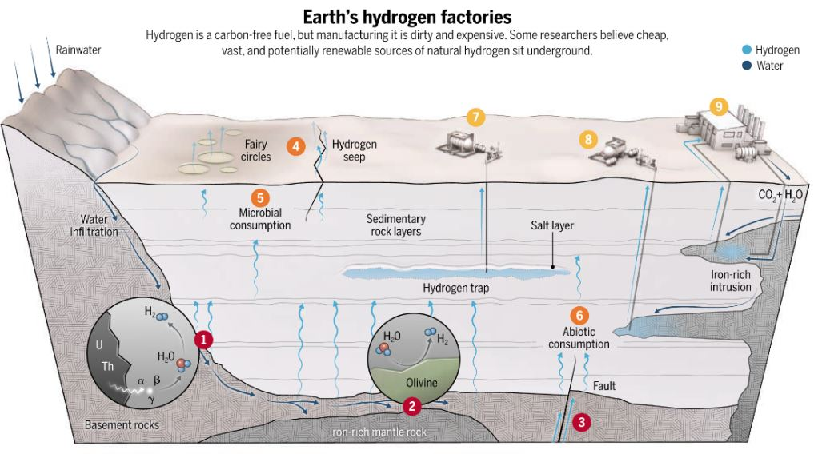
Image from (Staff., 2023)

Acknowledgment
I am grateful to the following individuals for their invaluable support in helping me complete this research project.
First, I would like to thank my supervisors, Karl-Heinz Wolf and William Rossen, for their support in completing this research paper. Their feedback and insight have been constructive in shaping the direction and scope of this research.
I would also like to express my gratitude to my father and brother for their help with this research paper.
I acknowledge the use of ChatGPT for language editing and, in the numerical-model revision, assistance with code correction and numerical verification.

Abstract
Natural or white hydrogen is emerging as a promising resource in the global transition toward sustainable energy. Unlike industrially produced hydrogen (green and blue), white hydrogen is generated naturally through geological processes such as serpentinization, radiolysis of water, mantle degassing, and rock weathering. Of the various methods, serpentinization is the most interesting for commercial use as it has a high and localized hydrogen production, making it an attractive option for exploration.
This study explores white hydrogen's geological and economic potential, focusing on its formation mechanisms, behavior in the subsurface, reservoir modeling, extraction, and hydrogen transportation methods. It highlights the parallels between hydrogen and petroleum systems and how such a comparison can help understand natural hydrogen for commercial use. For subsurface behavior, it is essential to factor in the role of faults, fractures, and porous rock formations in hydrogen migration and trapping. Advanced technologies such as seismic imaging, geophysical modeling, and specialized drilling techniques are essential for locating and extracting hydrogen efficiently.
The economic feasibility of white hydrogen extraction is supported by low estimated production costs of around $1 per kilogram, making it competitive with gray and blue hydrogen and significantly more affordable than green hydrogen. Transportation and storage methods, including compressed gas, cryogenic liquids, and innovative materials like metal-organic frameworks (MOFs), are critical to scaling white hydrogen for industrial and energy applications.
The revised numerical study compares a corrected material-balance tank, an immiscible gas–water model in Open-DARTS, and a compositional model inspired by the Bourakébougou hydrogen field. It separates gas already stored in the reservoir from prescribed external supply. These calculations examine extraction under stated assumptions; they do not establish that natural generation can sustain commercial production.
This essay concludes that white hydrogen has the potential to be a useful renewable energy source that can help replacing natural gas in several industrial processes, and can therefore contribute significantly to global decarbonization efforts. With further research in exploration and extraction, economic investment, and policy support, white hydrogen could play a significant role in helping humanity achieve its carbon-free future.

Table of contents
Acknowledgment 1
Abstract 1
Introduction 4
1. Types of natural Hydrogen production 6
1.1 Serpentinization 7
General serpentinization reaction 7
1.1.2 The effect of mineralogy on the H2 production in serpentinization 9
1.1.3 Effects of temperature, pressure, and water-to-rock ratio on serpentinization 10
1.2 Radiolysis of Water 11
1.2.1 introduction 11
1.2.2 The formation of hydrogen though radiolysis 12
1.2.3 Issues of Radiolysis 13
1.3 Degassing from Earth’s Crust and Mantle 13
1.4 Weathering of Rocks 14
2. Where the natural hydrogen can be found 15
2.1 The hydrogen generation dynamics 16
2.1.1 Serpentinization generation 17
2.2 Migration 17
2.2.1 Migration Pathways 17
2.2.2 Accumulation and Trapping 18
2.3 hydrogen generation from specific protoliths 19
2.3.1 Ophiolites 19
2.3.2 Greenstones 19
3. Behavior of hydrogen in the subsurface 20
3.1 Properties of gasses/liquids in the subsurface 20
3.1.1 Interaction of hydrogen with Water 22
3.1.2 Interaction of hydrogen with CO2 23
3.1.3 Interaction of hydrogen with Methane 23
3.1.4 Interaction of hydrogen with Nitrogen 24
3.1.4 Interaction of hydrogen with hydrogen sulfide 24
4. Exploration and reservoir conditions 25
4.1 Comparison of Hydrogen system to Petroleum system 25
4.1.1 Seismic Imaging 25
4.1.2 Drilling Techniques 25
4.1.3 Advanced Sensors and Monitoring: Catalytic Bead and Thermal Conductivity Sensors 26
4.1.4 Environmental Impact and Sustainability 26
4.2 General properties of Hydrogen in reservoirs 27
4.2.1 Properties of Hydrogen in Reservoir Rocks 27
4.2.2 Ideal Cap Rock Characteristics 28
5 Hydrogen extraction models 29
5.1 Purpose and assumptions 29
5.2 Storage and hydrogen properties 29
5.3 Conservation and well flow 30
5.4 Reconstructed minor scenario 31
5.5 Tank results and verification 32
5.6 First DARTS model for gas depletion 33
5.7 Compositional model for Bourakébougou 35
5.7.1 Phase behavior and flow 35
5.7.2 Scenario inputs and boundaries 36
5.7.3 Results and supply sensitivities 37
5.7.4 Numerical and property verification 37
5.8 Comparison and interpretation 38
6. Economic potentiality 38
6.1 White hydrogen compared to other hydrogen sources 38
6.1.1 green hydrogen costs 38
6.1.2 grey and blue hydrogen 39
6.1.3 White hydrogen 39
7. Hydrogen transportation 40
7.1 storage methods 40
7.1.1 compressed gas 40
7.1.2 Liquid hydrogen storage 41
7.1.3 LOHCs 42
7.1.4 Solid material hydrogen storage 42
7.1.5 MOFs 43
Means of Transportation 43
7.2.1 Pipeline Transport 43
7.2.2 Road transport 43
7.2.3 Ship transport 44
7.3 calculating the cost of transportation 44
Results 45
Conclusions 46
Reference list: 47
Appendix 53
Appendix 1 Reproducible model implementation 53
Appendix 2 Model figures and numerical records 55
Bourakébougou model files and figures 57

Introduction
White hydrogen, also commonly referred to as natural and sometimes as gold or geologic hydrogen, has emerged as a promising and relatively underexplored resource in the global transition toward sustainable and clean energy systems, unlike industrial hydrogen, produced through energy-intensive processes such as electrolysis (green hydrogen) or steam methane reforming (blue and gray hydrogen), white hydrogen forms through natural processes within the Earth’s crust and mantle. It can probably be extracted with a minimal environmental impact along with a low cost of extraction, unlike industrial hydrogen's high cost of production and greenhouse gas emissions. Based on recent studies, it appears that the Earth's crust might contain significantly more natural hydrogen than was previously estimated, potentially offering an abundant and cost-effective energy source. (Zgonnik, 2020) If white hydrogen is economically available, it has the potential to fill gaps in renewable energy production and serve as a major alternative to natural gas in industrial processes, which are vital for achieving global climate goals.
This essay assesses white hydrogen's geological and economic potential, considering its role as an energy carrier and a renewable resource. It seeks to answer several key questions, including:
- What natural processes cause white hydrogen to form in the subsurface?

- How does hydrogen behave in potential reservoir rocks, and what geological factors influence its accumulation and trapping?

- What extraction methods are most suitable for hydrogen recovery, and how do they compare to techniques used in petroleum systems?

- Is the extraction of white hydrogen economically viable, and how does it compare to other hydrogen production methods?

- To what extent can white hydrogen contribute to climate goals, including replacing natural gas in industrial processes?
The essay is divided into seven interconnected chapters to provide a comprehensive overview, each addressing a critical aspect of white hydrogen systems. Chapter 1 provides an in-depth exploration of the geological processes responsible for natural hydrogen production. These include serpentinization, a process in which ultramafic rocks react with water to produce hydrogen; radiolysis of water, driven by radioactive decay in the Earth's crust; hydrogen degassing from the mantle, often associated with volcanic and tectonic activity; and weathering of rocks, which generates hydrogen through the oxidation of iron-rich minerals. Among these, serpentinization stands out for its high production of hydrogen and a point localized production, making it the most promising process for natural hydrogen extraction.
Chapter 2 examines where natural hydrogen can be found and what geological conditions support its accumulation. Hydrogen migration and trapping are closely linked to the dynamics of faults, fractures, and porous rock formations. The chapter will discuss indicators for potential hydrogen reservoirs such as active tectonic regions, ultramafic rock outcrops, and features such as "fairy circles", surface depressions associated with hydrogen seepage. This chapter furthermore also discusses the similarities and differences between those of hydrogen and of petroleum systems, particularly in source, migration pathways, and accumulation mechanisms.
Understanding the behavior of hydrogen in subsurface environments is crucial for optimizing its eventual extraction and storage. Chapter 3 focuses on the interactions between hydrogen and other subsurface fluids, such as water, carbon dioxide, methane, hydrogen sulfide, and nitrogen. The chapter examines how temperature, pressure, and pore-scale properties influence the stability and movement of hydrogen. Key challenges, such as minimizing hydrogen loss through diffusion and chemical reactions, and strategies for enhancing hydrogen retention in reservoir rocks are addressed in this chapter.
Chapter 4 explores the technologies and methods used for locating and extracting natural hydrogen by drawing parallels to petroleum systems. Seismic imaging, geophysical surveys, and advanced drilling techniques are crucial for identifying and assessing the viability of hydrogen-rich reservoirs. Specialized tools, such as polymer casings to prevent hydrogen embrittlement and hydrogen-specific sensors, are highlighted as innovations tailored to hydrogen extraction. The chapter furthermore evaluates white hydrogen extraction's environmental impact and sustainability compared to traditional fossil fuel systems.
Chapter 5 develops three numerical models for natural-hydrogen extraction. A corrected tank model follows hydrogen mass and its pressure-dependent deliverability. A first Open-DARTS model adapts a conventional natural-gas depletion workflow to hydrogen and water. A second DARTS model uses observations from Bourakébougou, Mali, to investigate dissolution, exsolution and reservoir flow. The calculations distinguish literature observations, assumed reservoir properties and numerical verification.
Chapter 6 evaluates the economic potential of white hydrogen, comparing its costs to those of industrially produced hydrogen: green, blue, and gray hydrogen. With production costs estimated at around $1 per kilogram, white hydrogen offers a competitive advantage, particularly in regions with favorable geological conditions. The chapter highlights the role of advanced exploration technologies in reducing costs. It discusses the potential co-production of helium, which could further enhance the economic viability of white hydrogen projects.
Chapter 7 addresses both the challenges and solutions associated with hydrogen transportation and storage. The chapter discusses the various methods, including compressed gas, cryogenic liquids, liquid organic hydrogen carriers (LOHCs), and innovative materials like metal-organic frameworks (MOFs), which are explored for their suitability in different scenarios. The chapter emphasizes the importance of developing scalable, cost-effective, and energy-efficient systems for delivering hydrogen from reservoirs to industrial and energy markets.
This essay addresses these interconnected topics and comprehensively explains white hydrogen's geological, technological, and economic aspects. As the world seeks cleaner energy solutions to combat climate change, white hydrogen could bridge critical gaps in producing renewable energy and help replace natural gas in industrial processes. With increased research, investment, and policy support, natural hydrogen could play a major role in achieving global decarbonization goals and fostering a sustainable energy future.

1. Types of natural Hydrogen production
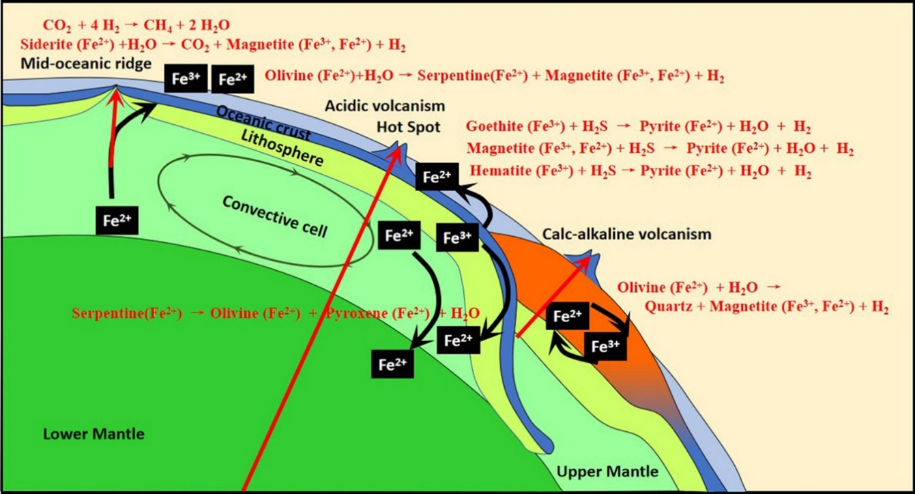
Image 1. Overview of hydrogen generation from mantle exhumation and water rock interactions (Arrouvel & Prinzhofer., 2021).

This essay discusses several types of natural hydrogen production. The types of hydrogen generation discussed here are the types that are most probable to be economically viable. The most financially viable types of hydrogen generation are water-rock interaction, radiolysis of water, Degassing of the earth’s mantle, and the weathering of rocks.(Zgonnik., 2020; Jackson et al., 2024) Water-rock is considered the most promising for extraction of the different forms of natural hydrogen production. The most effective form of water-rock interaction is the serpentinization. Other water-rock interactions can be present in the serpentinization reaction, such as pyritization. Serpentinization has the highest rate of hydrogen production when compared to other types of water-rock interaction. (Jackson et al., 2024)

The primary advantage of water-rock interaction, especially serpentinization, over other forms of hydrogen production, such as radiolysis of water, is that serpentinization provides a point source in time and space. Radiolysis also has the potential for high hydrogen production in Precambrian shield rocks ($0.05380195854{ m}^{3} of hydrogen per c\text{ubic kilometer }\text{of protolith per year}$ at standard temperature and pressure (STP). (Warr et al., 2019; Jackson et al., 2024) However, production rates from a serpentinization protolith can be much higher. For example, the hydrogen production rate from serpentinization of crushed pure olivine at 573K/35MPa with water/rock ratios of 1.0 would yield (5,151,666,885.2 m³⋅km⁻³⋅yr⁻¹). (Jackson et al., 2024) Expected source rocks, such as peridotite, which is composed of 80% olivine, would have a total yield of 25,485,120 m³ km⁻³ at 473K at standard pressure and a water/rock interaction of 1.0. In comparison, the rate of methane gas production in a typical hydrocarbon source is 135,920.86 m³⋅km⁻³⋅yr⁻¹. (Jackson et al., 2024)

Hydrogen exhalation from the mantle is less understood and depends on the composition of fluids in the mantle. As it is currently impossible to conduct in-situ measurements of the mantle, the amount of hydrogen generated from mantle exhalation is highly uncertain. However, diamonds from the mantle do indicate the presence of hydrogen. Weathering of rocks relates to iron formations, such as the banded iron formations (BIF), reacting with water. This reaction is slower than serpentinization due to buffering by hematite and magnetite, which are less reducing (Malvoisin & Brunet, 2023).
Due to serpentinization being the most effective and, therefore, most important process in the subsurface for the production of hydrogen, this chapter will focus mainly on how serpentinization functions, the effects of different minerals, temperatures/pressures, and the water/rock interaction on the formation of hydrogen. Because serpentinization is the most dominant water-rock interaction in the subsurface, other subsurface water-rock interactions will be discussed within the subchapter of serpentinization. A secondary focus will be on the radiolysis of water, which, despite having a lower yield than serpentinization, still makes up a large amount of the hydrogen generated worldwide. Degassing/exhalation from the mantle will be discussed as a potential, along with the uncertainty of the abundance of hydrogen in the mantle. The weathering of rocks will be discussed briefly as a minor source of natural hydrogen.
The known areas of H₂ production are all geologically active, which indicates that they only reduce the migration drive, allowing steady-state accumulation. Areas with significant upward movement of H₂ to the surface are characterized as “fairy circles,” circular depressions in the surface. These fairy circles are present in Russia, Mali, and the United States and have considerable concentrations of H₂ in the soils and the shallow drilling into the surface. (Zgonnik., 2020)

1.1 Serpentinization
Arguably, the most promising form of natural hydrogen generation is serpentinization, a process whereby ultramafic rocks are metamorphosed through hydrothermal processes, creating serpentine rocks. Serpentines are a group of rock assemblages mainly composed of serpentine minerals(Mg₃Si₂O₅(OH)₄). Serpentine rocks contain accessory minerals such as chromite, Ni-and Fe-sulfides, and native metal alloys such as awaruite(Ni₃Fe). The presence of accessory minerals can indicate the chemical and physical environment of the serpentinization process.(McCollom & Bach., 2009) Serpentinization occurs when ultramafic rocks are exposed to waters at temperatures below 673K to form serpentine, brucite, talc, and magnetite. Depending on the source rock's conditions, minor or trace elements and minerals such as NiFe-S, chlorite, tremolite with diopside, and garnet are present. If such elements or minerals are present, the process and the amount of hydrogen released can change substantially.(Klein, Bach & McCollom., 2013)
The generation of natural hydrogen from serpentinization results from water reacting with ferrous iron [Fe(II)] within minerals such as (ortho)pyroxene and olivine. The oxidization of [Fe(II)] to ferric iron [Fe(III)] causes the formation of serpentine series . The hydrogen is reduced to H₂ as either free hydrogen or dissolved in water. (McCollom & Bach., 2009) this is represented as:
$2{\left(FeO\right)}_{rock}+{\text{H}}_{2}{\text{O}}_{liquid}↔ {\left({\text{Fe}}_{2}{\text{O}}_{3}\right)}_{rock}+{\text{H}}_{2}$ reaction 1
This is a form of the Schikorr reaction which is generally represented as:
$3{Fe\left(OH\right)}_{2}↔{Fe}_{3}O_{4}+H_{2}+2H_{2}O$. reaction 2

General serpentinization reaction
Serpentinization is a metamorphic reaction of ultramafic rock where hydrogen is produced as a byproduct during serpentine formation and brucite. This process primarily occurs when peridotites, predominantly composed of olivine and (ortho)pyroxene, react with water under high pressure. The reaction of ultramafic rocks with water under the right pressure-temperature condition will cause the formation of serpentine minerals generating free hydrogen. (Jackson et al., 2024)
Serpentines originate from mantle blocks that have been displaced to the surface or shallow subsurface, where they are exposed to seawater or circulating groundwater. The minerals composing ultramafic rocks are stable at the high temperatures and pressures of the mantle, but they become unstable in the lower temperature range of the (shallow) subsurface and will react with water. (McCollom & Shock, 1998)
Serpentinization is controlled by three main factors: the pressure, the temperature, and the water-to-rock ratio. In most cases, water is not saturated at the protolith, so the olivine-to-serpentine reaction will already happen at temperatures far lower than those where the water is saturated. In such cases, serpentinization is controlled by water availability rather than pressure and temperature. (McCollom & Bach, 2009)
Depending on the composition of the bedrock, the serpentinization process can be significantly more complex. Carbon (C), nickel (Ni), and other heteroatoms introduce additional phases and reactions. (Steinthorsdottir et al., 2022) Natural hydrogen is best generated from olivine minerals. (Klein, Bach, & McCollom, 2013) Fayalite is the iron-rich end member of the olivine mineral, while forsterite is the magnesium-rich end member. Only fayalite is relevant for producing hydrogen from serpentinization, as forsterite produces magnesium and brucite rather than hydrogen.
For the generation of Hydrogen the hydrogen bearing reaction must reduce Gibbs free energy:
$Δ\text{G° = }Δ\text{H° - T}Δ\text{S°}$ equation 1
Where:
ΔG⁰ = Gibbs free energy
ΔH⁰ = change in enthalpy
T = temperature in Kelvin
ΔS⁰ = Change in entropy

During the reaction of serpentinization, water (H₂O) reacts with olivine (Mg_{1.8}Fe_{0.2}SiO₄) and pyroxene (MgSiO₃) to form serpentine minerals (Mg₃Si₂O₅(OH)₄), magnetite (Fe₃O₄), and hydrogen gas (H₂). In the serpentine reaction water transforms the ferrous Iron [Fe(II)] in the rock into ferric Iron [Fe(III)]. (FeO)_{rock} represents the ferrous component of igneous silicate minerals and (Fe₂O₃)_{rock} is the ferric component of the Fe bearing metamorphic minerals. (McCollom & Bach., 2009) The general hydrogen producing reaction is represented as:
$2({\text{FeO)}}_{rock}+{\text{H}}_{2}\text{O}↔{\left({\text{Fe}}_{2}{\text{O}}_{3}\right)}_{rock}+{\text{H}}_{2}$ reaction 3
For serpentinization [Fe(II)] is supplied by the olivine and magnetite, brucite and hydrogen are the reaction products. The general serpentinization reaction from olivine minerals is usually represented as:
${\text{Mg}}_{\text{1.8}}{\text{Fe}}_{\text{0.2}}{\text{SiO}}_{\text{4}}\text{+1.37}{\text{H}}_{\text{2}}\text{O}\text{ (l)}\text{↔0.5}{\text{Mg}}_{\text{3}}{\text{Si}}_{\text{2}}{\text{O}}_{\text{5}}\text{(OH}{\text{)}}_{\text{4}}\text{+0.3}{\text{Mg}\left(\text{OH}\right)}_{\text{2}}\text{+0.067}{\text{Fe}}_{\text{3}}{\text{O}}_{\text{4}}\text{+0.067}{\text{H}}_{\text{2}}\text{(g/aq})$ reaction 4
The serpentinization of olivine is mainly composed of two reaction a hydration reaction and a oxidation reaction. The hydration reaction has olivine (${\text{Mg}}_{1.8}{\text{Fe}}_{0.2}{\text{SiO}}_{4})$ react with water to form mineral serpentine ($3{\text{Mg}}_{3}{\text{Si}}_{2}{\text{O}}_{5}(\text{OH})_{4}$) and brucite (${Mg\left(OH\right)}_{2}+2\text{Fe}{\text{(}\text{O}\text{H)}}_{2}$):
${\text{Fe}}_{2}\text{Si}{\text{O}}_{4}+5{\text{Mg}}_{2}\text{Si}{\text{O}}_{4}+\text{9}{\text{H}}_{2}\text{O(l) ↔} 3{\text{Mg}}_{3}{\text{Si}}_{2}{\text{O}}_{5}(\text{OH})_{4}+{Mg\left(OH\right)}_{2}+2\text{Fe}{\text{(}\text{O}\text{H)}}_{2}$ reaction 5
The oxidization reaction transforms ferrous hydroxide Fe(OH)₂ into magnetite Fe₂O₄, water and hydrogen:
$6{\text{Fe(OH)}}_{2}↔2{\text{Fe}}_{2}{\text{O}}_{4}+4{\text{H}}_{2}\text{O(l)}+2{\text{H}}_{2}(\text{g/aq)}$ reaction 6
The fayalite and forsterite reactions can furthermore be separated:
$\text{6Fe}\text{2}\text{SiO}\text{4}\text{ (fayalite) + 7H}\text{2}\text{O(l) ↔ Fe}\text{3}\text{O}\text{4}\text{ (magnetite) + 3Fe}\text{3}\text{Si}\text{2}\text{O}\text{9}\text{H}\text{4}\text{ (greenalite) + H}\text{2}\text{(g)}$ reaction 7
And
$\text{2Mg}\text{2}\text{SiO}\text{4}\text{ (forsterite) + 3H}\text{2}\text{O (l) ↔ Mg}\text{3}\text{Si}\text{2}\text{O}\text{9}\text{H}\text{4}\text{ (chrysotile) + Mg(OH)}\text{2}\text{ (brucite)}$ reaction 8
At standard conditions, the fayalite reaction is exothermic (ΔH⁰ = −140.146 kJ mol⁻¹) and is spontaneous (ΔG⁰ = −83.858 kJ mol⁻¹). It remains spontaneous at 1 bar up to 438K. Assuming a geothermal gradient of 30$\frac{\text{K}}{\text{km}}$ the reaction remains stable until a depth of 11km. The forsterite reaction at standard conditions is spontaneous (ΔG⁰ = −49.401 kJ mol⁻¹) and up to 458K at 1 bar. With the same geothermal gradient, serpentinization takes place up to 11.5km. (McCollom & Bach., 2009)
Other geothermal reactions that form hydrogen are hematite formation from magnetite and hematite pyritization. Hematite formation from magnetite and pyritization are a function of the oxidation of [Fe(II)] to [Fe(III)]. The overall reaction is:
$\text{Fe}\text{3}\text{O}\text{4}\text{ (magnetite) + 6H}\text{2}\text{S (g) ↔ 3FeS}\text{2}\text{ (pyrite) + 4H}\text{2}\text{O(l) + 2H}\text{2}\text{(g)}$ reaction 9
It is spontaneous (ΔG⁰ = −218.883 kJ mol⁻¹) at standard conditions. It will occur down to 12km below the surface. This reaction depends on the availability of sulfur, which is more volatile, causing it not to be present in aqueous solution in crustal conditions. The reaction sulfur has to be in gaseous or supercritical condition for the reaction to occur.
Geochemical modeling has shown serpentinization to be significantly effective at generating a high hydrogen concentration and a low oxygen concentration (McCollom et al. 2016; Lazar 2020). The main controls on the serpentinization reaction are the composition of the parent rock, grain size, temperature, and water-to-rock ratio(McCollom et al., 2022). Although serpentinization can occur over a wide range of temperatures, experimental data shows that the optimal hydrogen production temperature range is between 473K and 573K (Klein et al. 2013; McCollom et al. 2022). In nature, the water supply for serpentinization can be provided by seawater, meteoric groundwater, or subduction-related aqueous fluids.

1.1.2 The effect of mineralogy on the H₂ production in serpentinization
Olivine minerals generate far more hydrogen during serpentinization than (ortho)pyroxene minerals. The reason olivine is more effective at generating hydrogen is that olivine serpentinization has fewer steps during the reaction than pyroxene, and unlike pyroxene, olivine doesn’t release silica, which inhibits hydrogen production. However, (ortho)pyroxenes can react faster in the earlier stages of serpentinization than olivine minerals, with mixtures that primarily contain olivine and produce similar levels of hydrogen to pure olivine minerals. Another important factor for the production of hydrogen is the pH level during serpentinization. With hydrogen generation rapidly increasing as the pH level increases to a strong alkaline condition. (McCollom et al., 2020)
The Schikorr reaction occurs due to iron oxidation within the mineral. The ideal mineral assemblage therefore has significant amounts of [Fe(II)] within the mineral structure, that are more stable when oxidized to [Fe(III)]. Minerals generated from serpentinization such as serpentine and brucite have a tendency to exclude [Fe(II)] from their structure. Due to serpentine and brucite excluding [Fe(II)], more [Fe(II)] will be oxidized, resulting in larger H₂ production through the Schikorr reaction. In contrast, minerals in basalt, such as chlorite and amphibole, readily integrate [Fe(II)] into their structure rather than converting it to [Fe(III)]. Because of the lack of converting [Fe(II)] to [Fe(III)], the hydrothermal alteration of basalt produces much lower amounts of H₂ compared to the serpentinization. (Blay-Roger et al., 2024)
Increases in magnesium lead to a slight increase in the generation of hydrogen up until forsterite, making up 70% of the olivine mineral (Fo70) for pressures of 50 [MPa]. Increased magnesium beyond Fo70 does not leave enough iron for significant magnetite formation. For iron concentrations in olivine above Fo70, the excess iron will be absorbed in the serpentine minerals rather than participate in the Schikorr reaction to form hydrogen. (Klein, Bach, & McCollom., 2013)
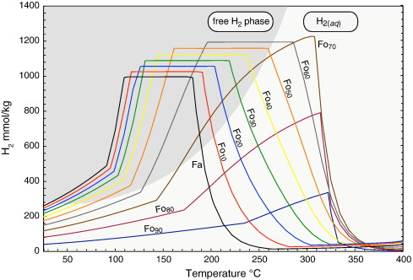
Image 2. H₂ production to temperature at 50MPa, based on magnesium to iron content in olivine. (Klein, Bach, & McCollom., 2013). Fo_{x} relates to percentage fosterite making up the olivine mineral

1.1.3 Effects of temperature, pressure, and water-to-rock ratio on serpentinization
The rate of serpentinization, as well as the H₂ generation, depends strongly on temperature, pressure, water-to-rock ratio, and mineral composition. At the temperature and pressure of the mantle, ultramafic rocks are stable and will not react to form serpentines. In environments with lower temperatures and pressures, ultramafic rocks become unstable and will react. This happens mainly in the (shallow) subsurface where water is present. Concentrations of H₂ increase with a decrease in the water-to-rock ratio. The temperature range for serpentinization increases with increasing pressure, with hydrogen production increasing significantly in the higher P/T range. (McCollom & Bach., 2009; Huang et al., 2020)
Table 1: behavior of the serpentinization reaction at different temperatures
Effect of hydrogen production at 50 MPa | Low-temperature range: 323K to 473K | Intermediate temperature range: 473K to 588K | High-temperature range: 588K to 663K
Effect of hydrogen production at 50 MPa | Serpentine dominates the equilibrium, with bruncite and magnitite being secondary in production | By far the highest in terms of Hydrogen production, although the water-to-rock ratio is less important | Medium in terms of production, the reaction to serpentinization is only partial in terms of production.

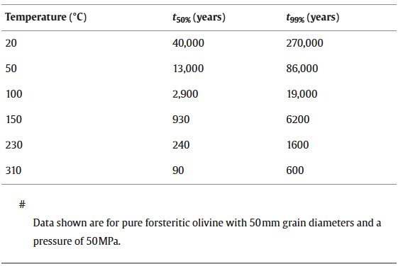
Image 3. Amount of serpentinization from olivine. (McCollom & Bach., 2009)

1.2 Radiolysis of Water

1.2.1 introduction
Water radiolysis occurs when water molecules are exposed to the ionizing radiation from elements such as uranium, thorium, and potassium. This radiation breaks the chemical bonds in water (H₂O), resulting in the formation of molecular hydrogen, oxygen (O₂), hydrogen peroxide (H₂O₂), and hydroxyl (OH). (Le Caër., 2011) In various geological settings this process can occur, such as in deep subsurface environments with radioactive minerals. (Parnell & Blamey., 2017)
For the radiolysis of water to function, water has to be close to the radioactive minerals. This isn’t rare, as water is the most common fluid inclusion in subsurface minerals. The radioactive sources are mainly decaying thorium, uranium, and potassium. The radiation emitted is in the form of α, β, and γ radiation, capable of breaking water bonds. (Bouquet et al., 2017) This process would gradually decline hydrogen emissions over millions of years. The abundance of potassium in the crust, which in terms of abundance is the seventh most common element in the subsurface, has been calculated as potentially high enough to compose half the hydrogen at the surface. (lin et al., 2005; Warr et al., 2019)
Hydrogen production through radiolysis has been observed in fluid inclusions within minerals such as sylvite, where potassium provides the necessary radiation(Parnell & Blamey., 2017). The effect of water radiolysis is in uranium ores, where discrete amounts of hydrogen and oxygen are found in an aqueous solution. With a lower amount of uranium, thorium, and potassium in ores, the amount of hydrogen and oxygen in said ores decreases. Research from the USSR showcases elevated hydrogen concentrations in potassium evaporites, especially for sylvite and carnallite. Hydrogen concentrations in deep groundwaters may reflect long-term radiolysis. (Parnell & Blamey., 2017)

1.2.2 The formation of hydrogen though radiolysis
Hydrogen production from water radiolysis has three main steps: the physical, physico-chemical, and chemical stages. The physical stage relates to the ionizing radiation of matter. The physicochemical stage relates to the ionization of excited states and the reaction between ions and molecules. The chemical stage concerns the diffusion of the various species, followed by their reaction to form molecules.
The physical stage happens about 1 femtosecond after the initial radiation interacting with the water molecule. This stage involves energy being deposited in the water molecules, creating ionized water molecules [H₂O⁺], exited water molecules[H₂O*] and sub-excitation electrons[e⁻].
The physico-chemical stage, which lasts from 10–15 to 10–12 seconds, includes a variety of processes such as reactions between ions and molecules, molecules breaking apart, exited states becoming ionized, and electrons becoming solvent. The pysico-chemical stage happens in the following steps(Ali et al., 2023);
${\text{H}}_{2}{\text{O}}^{+}+{\text{H}}_{2}\text{O}→{\text{H}}_{3}{\text{O}}^{+}+{\text{OH}}^{*}$ reaction 10
${\text{H}}_{2}{\text{O}}^{*}+{\text{HO}}_{2}→{\text{OH}}^{*}+{\text{H}}^{*}$ reaction 11
${\text{e}}^{-}→e_{\text{aq}}^{-}$ reaction 12
In the chemical stage the various species interact and diffuse, reacting with neighboring molecules, forming oxygen and molecular hydrogen.
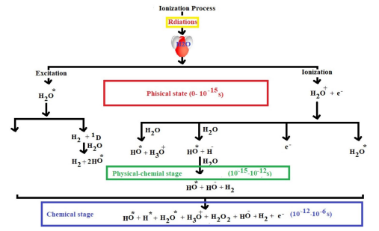
Image 4. Steps of hydrogen formation through radiolysis. (Ali et al., 2023).

1.2.3 Issues of Radiolysis
Despite the potential of radiolysis-driven hydrogen production, making up a large amount of natural hydrogen produced in the world, several challenges remain. As the hydrogen is split from oxygen, it can react with oxygen again to form water. Natural hydrogen from radiolysis is likely produced from water locked inside the mineral containing radioactive material, making the movement of hydrogen difficult. (Bouquet et al., 2017) If the movement of hydrogen is difficult, the potential of the hydrogen to react with oxygen or other compounds is higher. The main issue of radiolysis compared to serpentinization regarding economic potential, is that serpentinization is local and produced at a higher rate. Furthermore, serpentinization has a positive feedback loop when it comes to hydrogen generation: by causing further fractures in the faults causing a positive feedback loop for hydrogen generation (Warr et al., 2019). As faults are the “highways” of hydrogen movement, this is ideal for hydrogen extraction. Radiolysis causes more background radiation of hydrogen.

1.3 Degassing from Earth’s Crust and Mantle
The Earth continuously emits/degasses hydrogen. Hydrogen emitted from the Earth can be classified as the result of ‘hot’ or ‘cold’ exhalation. Hot exhalation is related to volcanic activity, characterized by oxidized gas species. Cold exhalation relates to gas seepage from sources such as surface depressions, faults, and pockmarks. Cold exhalation is from the reducing conditions of Earth’s mantle. Especially Cold exhalation is understudied as it occurs in the background of other geological activities. (Zgonnik., 2020) The degassing of hydrogen is a continuous process that contributes to the presence of hydrogen in the Earth’s atmosphere and subsurface environments (Leila et al., 2023).
In hot exhalation environments of volcanoes, hydrogen is the third most common gas emanation. The presence of hydrogen is thought to depend on the nature of the lava due to the composition of the gases being in thermal equilibrium with specific composition of the molten rock rather than the thermal water decomposition, as this only occurs at low pressure 0.01 MPa and very high temperatures of between 2000 K to 3000 K. decomposition of hydrogen sulfides are also considered for hydrogen degassing. (Zgonnik., 2020)
Metal inclusions in diamonds, which form in depths equivalent to that of the Earth's mantle, strongly indicate the presence of hydrogen, confirming its presence in the mantle (Smith et al., 2016). If the Earth’s upper mantle, along with significant portions of the asthenosphere, is metal-saturated, they should have strong reducing conditions. The metal saturation leads to the reducing conditions in the mantle and asthenosphere; the fluid composition should therefore be rich in hydrogen (Rohrbach et al., 2007). This is because the metal saturation in the mantle favors redox reactions, leading to an increased presence of H₂ as the C-O-H fluids will be dominated by CH₄/H₂O/H₂ composition rather than a CO₂/H₂O composition. (Zgonnik., 2020)
Recent studies have shown that significant amounts of hydrogen can be released from deep underground reservoirs. It has been showcased that in the Albanian Bulqizë chromite mine, an outgassing rate of 84% hydrogen of the total emitted volume, yielding 200 tons of hydrogen at minimum, is released annually. (Truche et al., 2024) The chromite mine is part of a Jurassic ultramafic deposit. It appears that there are multiple sources for the white hydrogen production. This is a combination of outgassing from the mantle through fault networks, serpentinization, and the release of paleo fluids. (Truche et al., 2024). This results from the inability to drill down to the mantle or the planet's core to find hydrogen generation in situ.

1.4 Weathering of Rocks
Weathering of rocks involves the breakdown and alteration of minerals at the Earth’s surface due to chemical, physical, and biological processes. In particular, the oxidation of iron-rich minerals during weathering can produce molecular hydrogen H₂. (Geymond et al., 2022) This process is significant in oceanic and continental domains, where the interaction between water and ferrous rocks results in hydrogen generation (Geymond et al., 2023).
Recent studies have shown that the weathering of banded iron formations (BIFs) have the ability to generate significant quantities of hydrogen. BIFs are a type of sedimentary rock composed of iron-rich minerals and silica, and their weathering oxidizes the iron, leading to the production of hydrogen. (Geymond et al., 2022) These findings are important in furthering the understanding of the potential of weathering processes to contribute to natural hydrogen reserves that can be harnessed for energy purposes.
The formation of natural hydrogen through water reduction and iron oxidation during BIF alteration would also use the Schikorr reaction. While hydrogen generation is most effective at high P/T conditions (50 to 200 and temperatures up to 630K), with a catalyst such as magnetite, goethite, and hematite, it can also occur at near-atmospheric conditions. Studies showcase that natural hydrogen generation at near-atmospheric conditions is significantly slower than at high P/T conditions. (Irfan et al., 2019)
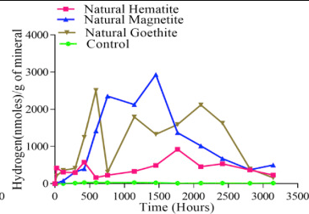
Image 5 Hydrogen generation in nmoles/g of mineral from weathering of rocks. (Irfan et al., 2019)
In petrographic studies, it has been demonstrated that BIF-hosted ore formations originate as a result of the circulation of oxidizing fluids. Experiments simulating shallow oxidizing of BIF showcase that all [Fe(II)] is converted to [Fe(III)]. (Geymond et al., 2022)

2. Where the natural hydrogen can be found
It is important to note that the types of hydrogen production can overlap with the generated hydrogen present. The forms of hydrogen production that tend to dominate are serpentinization and radiolysis of water. For hydrogen generated deep in the Earth, faults and fractures help the generated hydrogen move up quickly to the surface; if substantial hydrogen is generated from the mantle, faults that reach the mantle would function as ‘highways’ to recover said hydrogen. (Zgonnik., 2020)
Serpentinization appears in Mid-oceanic ridges, hyper-extended passive margins, ophiolites, deformed oceanic crust, and intra-plate continental margins. One interesting case for serpentinization is the ring of fire, where active subduction of oceanic plates takes place along with the hydration of the oceanic plate. As the subducted plate descends, it undergoes high-pressure and high-temperature conditions, leading to the serpentinization of ultramafic rocks (Zoheir et al., 2024).
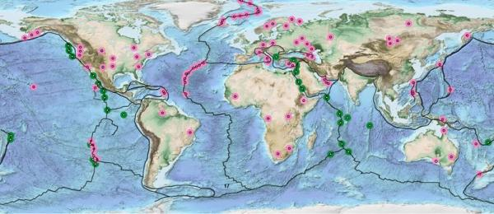
Image 6 Locations of natural hydrogen. (Natural Hydrogen: A Geological Curiosity or the Primary Energy Source for a Low-carbon Future?, 2021)
As hydrogen from serpentinization is linked to ultramafic rocks, locating ultramafic rocks in the geological layers is crucial. Ultramafic rocks can be found in ophiolites and uplifted plutonic rocks. Ultramafic rocks also influence volcanic activity, such as in the ring of fire. The subduction of oceanic plates leads to the melting of these rocks, forming magma that rises to the surface and creates volcanic arcs. (Lemke et al., 2024) The process contributes to the generation of hydrogen gas and plays a role in the formation of hydrothermal vents. These vents release hydrogen, methane, and hydrogen sulfide, providing energy sources for deep-sea chemotrophic microorganisms. (Lukose et al., 2024) This makes the ring of fire an interesting location for locating potential serpentinization hotspots. Other interesting features are fairy spots and hydrogen blooms that can be used to locate large quantities of hydrogen.

2.1 The hydrogen generation dynamics
The hydrogen system is introduced as an analog to the petroleum system, which is used to understand petroleum generation and migration. The main difference with regard to system dynamics between the two systems is that in petroleum systems, the source rock is within the basin, and the petroleum system is part of the basin, while in hydrogen systems, the source rock is located in the basement rock and geologically separated from the sedimentary rock it migrates through.
Natural hydrogen can be generated from serpentinization, radiolysis of water, degassing of hydrogen from the mantle, and weathering of rocks. Compared to petroleum systems, whose generation of hydrocarbons can take tens of millions of years, the generation of hydrogen can be considered instantaneous. The volume of hydrogen generation from water through the various types of hydrogen generation is dependent on the conditions of the protolith. Of the various types of hydrogen generation discussed in this essay, serpentinization is the best understood followed by radiolysis and weathering of rocks. Degassing from the mantle is poorly understood and is based on hypothetical compositions of the mantle. Serpentinization has a significantly higher rate of production than the weathering of rocks. Radiolysis has a high estimate for total generation of natural hydrogen but it is not as local and ‘fast’ as white hydrogen. This chapter will discuss the serpentinization hydrogen system (2.1.1) as this is the best candidate for hydrogen exploration.
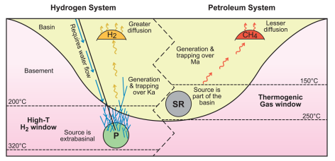
Image 7 Comparison of a hydrogen system to a petroleum system. (Jackson et al., 2024)

2.1.1 Serpentinization generation
With serpentinization, hydrogen is generated from the contact of water with specific ultramafic rocks such as olivine and (ortho)pyroxene. The ultramafic rock serves as the protolith. The simplest way for hydrogen to escape from the protolith is in aqueous solution. Hydrogen is generated as a gas below 523K; it is generated as an aqueous solution at higher temperatures. At 200 MPa, when the temperature drops below 523K, dissolved gas can separate out of the solvent. (Lazer., 2020). With an increase in pressure, the serpentinization reaction requires lower temperatures for the procurement of hydrogen gas. An advantage of serpentinization is that it is effective at procuring hydrogen, creating high levels of hydrogen in the solution. A high concentration of hydrogen in the solution means that less water is needed to drive the reaction and transport of hydrogen. During serpentinization, the reaction causes fractures in the protolith, allowing hydrogen to escape and increasing the surface area of the protolith for reaction with water. Tectonic activity can further speed up hydrogen release from the protolith and movement towards the surface. The hydrogen released from the protolith can move with water in fault zones and as a gas through fractures. Higher up, it can get trapped by moving into sediments. (Lazer., 2020)
Water for the serpentinization reaction can come from seawater, groundwater, or fluids from subduction zones. The source and the plumbing system (how water gets to the rock) depend on the geological setting. The rate of water supply and how easily it reaches the rock are crucial for the process (described as ‘flush vs. trickle’). The timing of this interaction also matters for the resource potential. If serpentinization happens ‘late’ (in the last few thousand years), the resource might be replenishable. (Jackson et al., 2024)

2.2 Migration

2.2.1 Migration Pathways
The migration of hydrogen is facilitated by the geological formations and structures such as faults, fractures, and porous rock formations present in the subsurface. These pathways allow for hydrogen to move from its source to its potential accumulation zones. The migration process is depends on factors such as pressure, temperature, and the presence of other gases and fluids. Faults and fractures in the Earth's crust are conduits for hydrogen migration. Faults and fractures can extend deep into the earth, providing pathways for hydrogen to move upwards. The permeability of these pathways is important for the efficient migration of hydrogen. Faults and fractures can create interconnected networks, allowing for hydrogen to travel long distances. The movement of hydrogen through these pathways is influenced by the pressure and temperature conditions in the subsurface and the presence of other gases and fluids that can either facilitate or hinder hydrogen migration (Donzé et al., 2020).
Porosity is important for the migration of rocks. Sandstones and carbonates are porous formations that can facilitate hydrogen migration. These formations have interconnected pore spaces that allow hydrogen to move through them. The porosity and permeability of rocks such as carbonates and sandstoens determine the ease with which hydrogen can migrate. High-porosity rocks can store significant amounts of hydrogen, while high-permeability rocks allow for efficient movement of hydrogen through the subsurface. The migration of hydrogen through porous rock formations is also influenced by the P/T conditions and other fluids present in the subsurface, which can affect hydrogen flow. (Jackson et al., 2024).

2.2.2 Accumulation and Trapping
Hydrogen can accumulate in subsurface reservoirs if it encounters impermeable rock layers that act as seals. These seals prevent the hydrogen from escaping to the surface and are usually composed of shales that do not react with hydrogen. The trapping mechanisms for hydrogen are similar to those for hydrocarbons, involving structural and stratigraphic traps. For hydrogen, advective flow dominates until the capillary forces in the pores in low-permeability rocks dominate over buoyancy pressure. While hydrogen has a greater buoyancy than hydrocarbons, hydrogen column heights can be retained by capillary forces beneath lithologies that can typically effectively seal formations for methane. (Hutchinson et al., 2024) As hydrogen has a low solubility, the presence of water constrains its diffusive losses. Countering its diffusive character. There are two main traps to be considered for hydrogen structural traps and stratigraphic traps:
Structural traps are formed by the deformation of rock layers, creating folds or faults that can trap hydrogen. Anticlines, fault traps, and salt domes are examples of structural traps that can hold hydrogen (Jackson et al., 2024).
- Anticlines: These arch-like folds in rock layers create a dome shape. Hydrogen can accumulate at the crest of the anticline, where the rock layers are bent upwards.
- Fault Traps: These occur when rock layers are displaced by a fault. The movement along the fault can create a barrier that traps hydrogen on one side of the fault.
- Salt Domes: These are formed when a large mass of salt, which is less dense than the surrounding rock, moves upwards through the rock layers. The salt dome can create spaces where hydrogen can accumulate.
Stratigraphic traps are formed by variations in rock layers, such as changes in porosity or permeability. These traps can occur where impermeable layers seal porous rock layers, preventing the hydrogen from escaping (Donzé et al., 2020). Stratigraphic traps rely on differences in the porosity and permeability of rock layers. Porous rocks can store hydrogen, while impermeable rocks can act as a seal. Stratigraphic traps often occur in sedimentary basins where rock layers have different properties. For example, a layer of sandstone with high porosity may be overlain by a layer of shale with low permeability, creating a trap for hydrogen. The effectiveness of a stratigraphic trap depends on the quality of the seal. Impermeable layers such as shale or salt can create effective barriers that trap hydrogen.
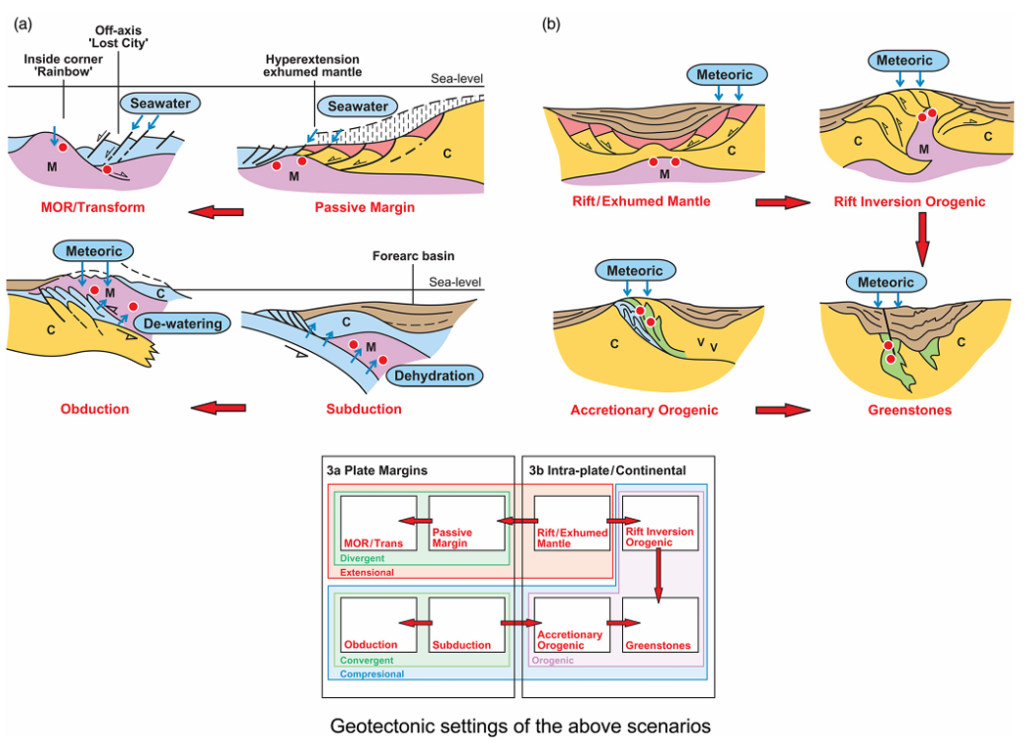
Image 8 Geotectonic settings for hydrogen production. This figure illustrates the geotectonic environments where serpentinization and hydrogen generation occur. It includes: (a) Plate margin settings, which encompass divergent and convergent margins (ophiolites). (b) Intra-plate continental settings, which include intra-cratonic rifts, orogenic belts, and greenstones. (Jackson et al., 2024).

2.3 hydrogen generation from specific protoliths
On the continental crust, serpentinization happens at ophiolites and greenstones, which can produce significant amounts of hydrogen. Ophiolites tend to contain rocks with a higher olivine concentration than greenstone ones.

2.3.1 Ophiolites
Ophiolites are the uplifted and exposed parts of the oceanic crust and upper mantle to continental crust. They are rich in ultramafic rocks, such as peridotite, which undergo serpentinization, a process where water interacts with these rocks to form serpentine minerals and release hydrogen gas. The hydrogen production rate in ophiolites varies depending on the geological conditions and the extent of serpentinization. For example, the Bulqizë ophiolite in Albania has been reported to vent approximately 200 tons of hydrogen annually, corresponding to a mass flow rate of about 0.0063 kg/s (UNECE, 2024). The Samail Ophiolite in Oman, one of the largest exposed complexes of ultramafic rocks, also produces a continuous flux of hydrogen through low-temperature water/rock reactions enough to have a production of 0.0022 kg/s of H₂ (GeoScienceWorld, 2024).

2.3.2 Greenstones
Greenstone belts are typically found in ancient craton regions. These belts are composed of volcanic and sedimentary rocks that have undergone low-grade metamorphism. Serpentinization processes primarily drive hydrogen production in greenstone belts. (MDPI, 2024). The Barberton Greenstone Belt in South Africa, one of the oldest and most well-studied greenstone belts, covers an area of approximately 120 kilometers long and 60 kilometers wide, with an average thickness of about 5 kilometers. This gives it an approximate volume of around 36,000 cubic kilometers. (GeoScienceWorld, 2024)

3. Behavior of hydrogen in the subsurface

3.1 Properties of gasses/liquids in the subsurface
The formation of natural hydrogen during serpentinization is in an aqueous solution, so to know how much hydrogen can be produced, we have to look at the behavior of hydrogen in an aqueous solution first, as well as hydrogen interaction with other solvents.
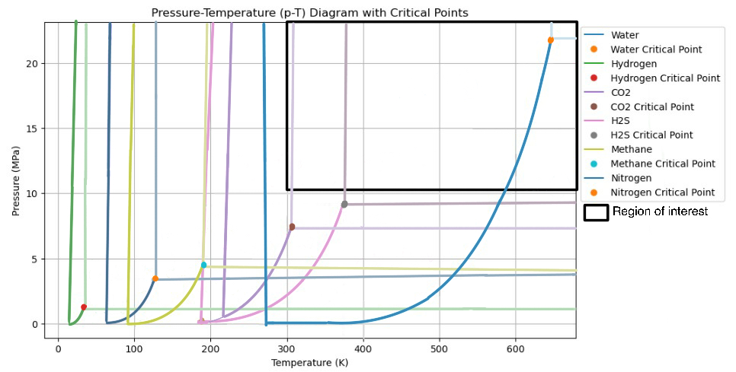
Image 9 Low pressure zone of the noted species most likely to interact with hydrogen in the subsurface. Data from engineering toolbox. This does include the full H₂S phase diagram.

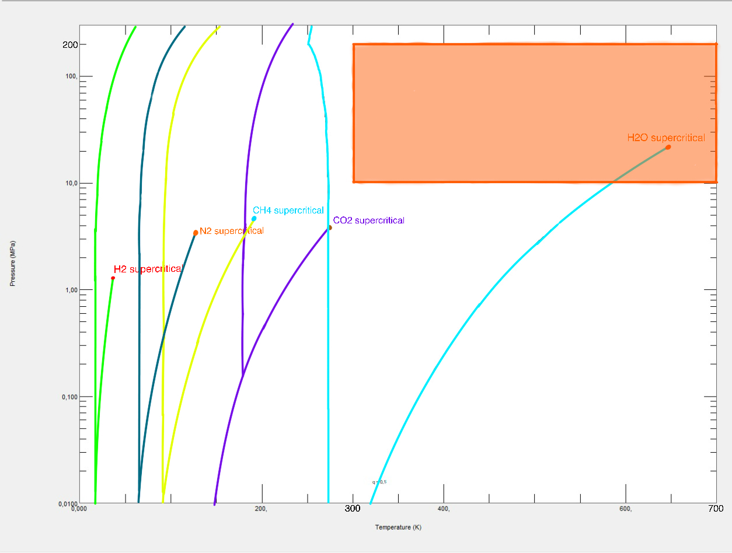
Image 10 High pressure figure containing all the species except H₂S that are likely to interact with hydrogen. The orange region is the zone where serpentinization that is economically viable can take place. Data from minirefprop.
 | Carbon Dioxide: CO₂ | Water: H₂O | Hydrogen H₂ | Methane CH₄ | Nitrogen N₂ | Hydrogen sulfide: H₂S
Molar Mass: | 44.009 g/mol | 18.013 g/mol | 2.016 g/mol | 16.04 g/mol | 28.0134 g/mol | 34.08 g/mol
Melting point | -56.5 °C | 0.00 °C | -259.16 °C | -182.456 °C | -209.86°C | -85.5°C
Sublimation point at 1 bar | -56.558 °C | 99.8 °C | -252.879 °C | -161.5 °C | -210°C | -85.5°C
Freezing point | -78.48 °C | 0.00 °C | -259.16 °C | -182.5 °C | -210°C | -85.5°C
triple point | -56.558 °C | 0.01 °C at 0.006 atm | -259.3 °C at 0.0704 atm | -182.48 °C | 63.14 K and 0.125 atm | -85.5°C at 0.0128 atm
Density:  Solid, Liquid, gas | Solid:  - 1562 kg/m³ at −78.5 °C and 1 atm  Liquid:  - 1101 kg/m³ at saturation −37 °C  Gas:  - 1.977 kg/m³ at 0 °C and 1 atm | Solid:  - 916.7 kg/m³ at 0 °C  Liquid:  - 999.8 kg/m³ at 0 °C  - 997.0 kg/m³ at 25 °C  - 961.9 kg/m³ at 95 °C  Gas:  - 0.598 kg/m³ at 1 atm and 100°C | Solid:  - 76.3 kg/m³ at -260.15 °C and 1 atm  Liquid:  - 70.85 kg/m³ at -253 °C and 1 atm  Gas:  - 0.0899 kg/m³at 0°C and 1 atm | Solid:  - 422.6 kg/m³ at -162°C  Liquid:  - 424 kg/m³ at -164°C  Gas:  - 0.7168 kg/m³ at 0°C and 1 atm | Solid:  - 1026.5 kg/m³ at -210.01°C  Liquid:  - 807 kg/m³ at its boiling point of -196°C  Gas:  - 1.2506 kg/m³ at 0°C and 1 atm | Solid:  - 1.46 kg/m³ at -85.5°C  Liquid:  - 0.92 kg/m³ at -60°C  Gas:  - 1.539 kg/m³ at 0°C
Vapour pressure | variable | 3.169 kPa | variable | 62.12 MPa at 25°C | variable | 1740 kPa at 21°C
Heat capacity (C) | 37.135 J/( mol·K) | 75.385 ± 0.05 J/(mol·K) | 28.836 J/(mol·K) | 35.8 J/(mol·K) | 29.124 J/(mol·K) | 34.08 J/(mol·K)
Thermal conductivity | 0.01662 W/(mol·K) (at 300K) | 0.6065 W/(mol·K) | 0.1805 W/(mol·K) (at 300K) | 0.034 W/(mol·K) (at 300K) | 0.02598 W/(mol·K) (at 300K) | 0.017 W/(mol·K) at 25°C
Liquid viscosity | variable | 0.890 cP | 0.0132 cP | 0.01107 cP (at boiling point) | 0.018 cP (at boiling point) | 0.0125 cP (at 25°C)
Solubility in water for hydrogen: At 25°C and 1 atm, the mole fraction of hydrogen in water is approximately 8.1 x 10⁻⁷
CO₂ decomposes above 2000 K producing carbon monoxide.
Solubility in water: 0.704*10⁻³ mole fraction of CO₂ in the liquid phase at 25 °C (gas at a pressure of 101.33 kPa)
Solubility in water for methane: At 25°C and 1 atm, the mole fraction of methane in water is approximately 1.4 x 10⁻⁵
Both hydrogen and methane will be in the supercritical phase in the subsurface.
Table 2: properties of various subsurface gasses
(BYJU’s., 2022;Engineeringtoolbox., 2024a; Engineeringtoolbox., 2024b; Engineeringtoolbox., 2024c Engineeringtoolbox., 2024d; Engineeringtoolbox., 2024e)

3.1.1 Interaction of hydrogen with Water
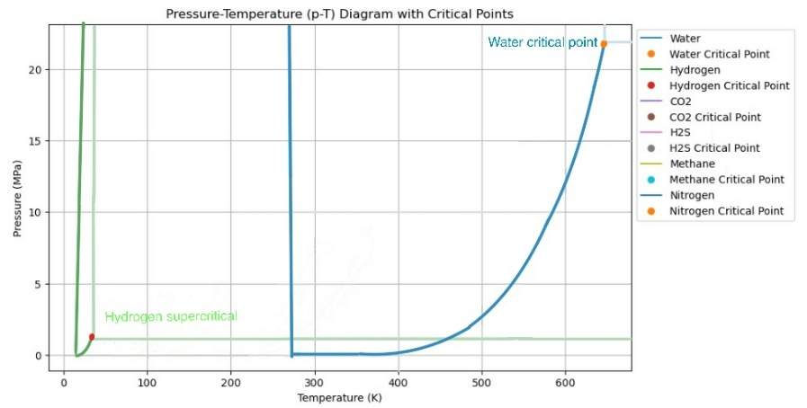
Hydrogen has a low solubility in water under standard conditions. Under high-pressure conditions, the solubility of hydrogen in water increases. To maximize hydrogen accumulation, it is essential to manage the water content in the subsurface environment. Water does have a far higher absorption ability for carbon dioxide than for hydrogen. This can result in much carbon dioxide reacting with the hydrogen. High concentrations of water cause the formation of hydrogen bonds, increasing potential reactions with dissolved CO₂, forming methane through the Sabatier reaction:
Image 11 While hydrogen forms from water during serpentinization, interaction with water results in a lower amount of hydrogen.
${\text{CO}}_{2}+4{\text{H}}_{2}→ {\text{CH}}_{4}+2{\text{H}}_{2}\text{O}$ reaction 13
Minimizing water content can reduce these reactions, thereby preserving more hydrogen (Sabatier reaction, 2023).

3.1.2 Interaction of hydrogen with CO2
Under standard temperature and pressure conditions CO₂ easily dissolves in water, causing the formation of carbonic acid (H2CO3). In the presence of hydrogen, CO₂ can be reduced to form methane, decreasing the amount of free hydrogen. To maximize hydrogen accumulation, it is imperative for CO₂ levels in the subsurface to be minimal. This can be achieved by ensuring that the subsurface environment is carbonate undersaturated, which limits the availability of CO₂ for reaction with hydrogen (Franok, 1987).
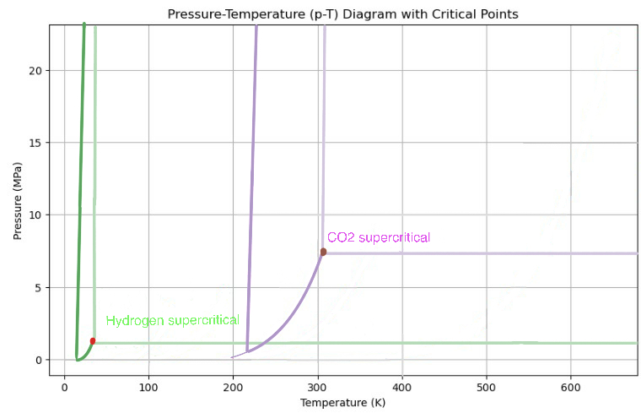
Image 12 Hydrogen and CO₂ phase diagram.

3.1.3 Interaction of hydrogen with Methane
Methane can form clathrate hydrates with water, trapping methane molecules within a lattice of water molecules. The presence of hydrogen can influence the stability and formation of these hydrates. To maximize hydrogen accumulation, managing methane levels and preventing the formation of mixed gas hydrates which can trap hydrogen is important. Lower temperatures can help with ensuring a higher concentration of hydrogen(Franok, 1987).
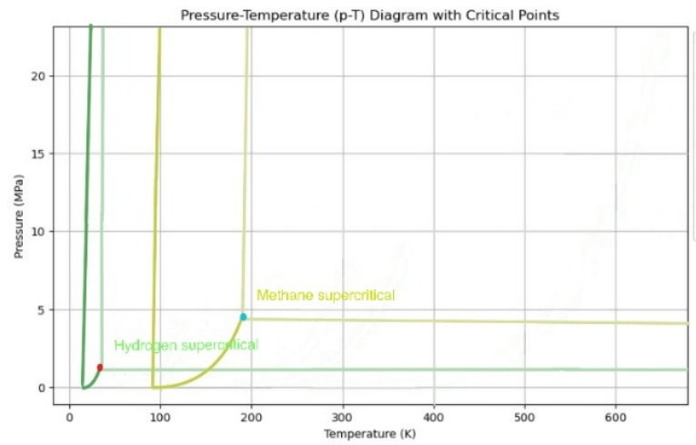
Image 13 Hydrogen and methane exhibit relatively similar behavior in terms of pressure temperature range.

3.1.4 Interaction of hydrogen with Nitrogen
Hydrogen and nitrogen gases through interaction can form ammonia (NH₃). This happens through the Haber-Bosch process, which requires high temperatures and pressures. Under standard temperature and pressure, nitrogenase enzymes catalyze the conversion of nitrogen to ammonia, with hydrogen as a byproduct. To maximize hydrogen accumulation, it is essential to manage nitrogen levels as well as preventing conditions that favor the formation of ammonia. Combatting the formation of NH₃ can be done by controlling the temperature and pressure conditions so as to minimize the interaction between hydrogen and nitrogen (Max-Planck-Institut, 2024). Therefore, lowring temperature of a reservoir containing nitrogen is essential if possible.
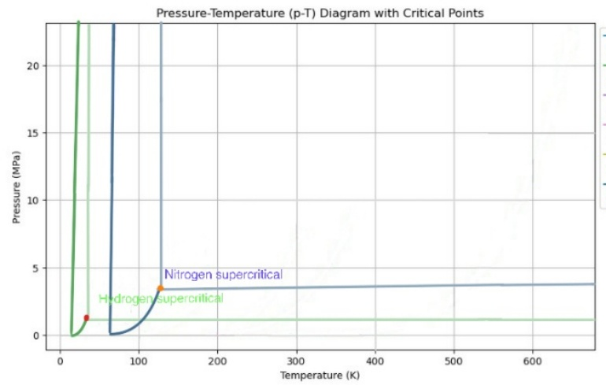
Image 14 Hydrogen and nitrogen phase diagram.

3.1.4 Interaction of hydrogen with hydrogen sulfide
The interaction between hydrogen (H₂) and hydrogen sulfide (H₂S) in reservoirs can significantly impact reservoir stability. H₂ and H₂S can react to form sulfur and water, influenced by temperature, pressure, and catalysts. This reaction can lead to clogging and reduced permeability in the reservoir (Fu et al., 2016). Subsurface microorganisms can metabolize H₂, producing H₂S, which can cause hydrogen losses, clogging, and formation damage, negatively affecting reservoir stability (Tremosa et al., 2023). The interaction between H₂ and H₂S can alter the reservoir's geochemical environment, affecting porosity and permeability through changes in pH and redox conditions (Cheng et al., 2022).
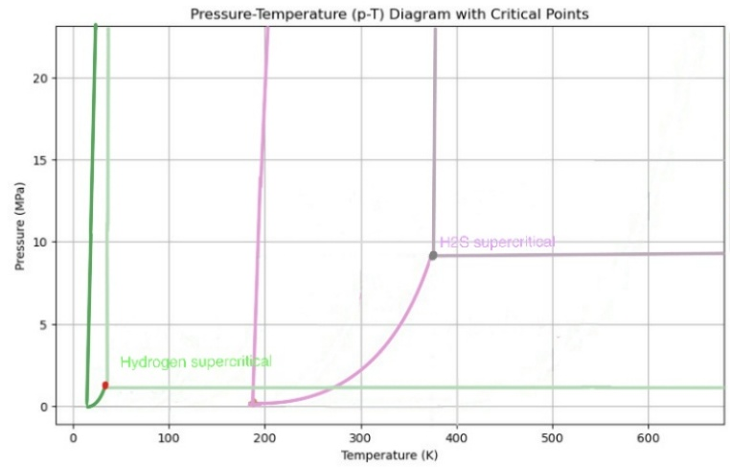
Image 15 Hydrogen and H₂S phase diagram.

4. Exploration and reservoir conditions

4.1 Comparison of Hydrogen system to Petroleum system

4.1.1 Seismic Imaging
Seismic imaging is an important technology and method for both petroleum and potentialy for white hydrogen extraction. Seismic imaging involves sending seismic waves into the ground and analyzing the seismic waves the have been reflected to create a detailed map of subsurface structures. In petroleum engineering, seismic imaging helps identify oil reservoirs and assess their size and shape. The process involves deploying seismic sources, such as dynamite or vibroseis trucks, which generate controlled energy waves. The seismic waves travel through the earth reflecting and refracting off different geological layers. Geophones or hydrophones then capture the reflected waves, and the data is processed to create a three-dimensional image of the subsurface.
Similarly, seismic imaging is used to locate hydrogen chimneys and local accumulations in white hydrogen extraction. Hydrogen chimneys are vertical structures where hydrogen gas migrates from deep geological formations to shallower depths. Hydrogen chimneys can be recognized from chaotic seismic reflections, having large vertical columns Identifying these chimneys is crucial for efficient extraction. (Sunjay., 2024) The precision of seismic imaging is vital for both industries to minimize drilling risks and optimize resource recovery. Advanced seismic techniques, such as 4D seismic monitoring, have also been employed in tracking changes in the reservoir over time, adding further insights into the behavior of the resource during extraction (Smith, 2023).

4.1.2 Drilling Techniques
Drilling is a central technology used in petroleum extraction and could potentially be used in white hydrogen extraction. The drilling process involves several stages, including spudding, casing, and completion. Steel casings are typically used in petroleum extraction to line the wellbore and prevent collapse. These casings are cemented in place to provide structural integrity and isolate different geological formations.
In contrast, white hydrogen extraction often employs polymer casings to prevent hydrogen embrittlement, a phenomenon where hydrogen weakens metal structures. Hydrogen embrittlement occurs when the hydrogen atoms diffuse into the metal structure and cause the structure to become brittle and prone to cracking. Polymer casings, made from materials such as high-density polyethylene (HDPE), are resistant to hydrogen embrittlement and provide a safer alternative for hydrogen wells. Additionally, drilling techniques for hydrogen extraction may involve using specialized drilling fluids to help manage problems related to the low density and high diffusivity of hydrogen (Jones & Brown, 2022).

4.1.3 Advanced Sensors and Monitoring: Catalytic Bead and Thermal Conductivity Sensors
As both hydrogen and hydrocarbons are volatile substances, the utilization of advanced monitoring systems and sensors is crucial. These technologies allow for constant, real-time data collection on parameters like pressure, temperature, and gas composition. For example, in petroleum extraction, sensors can measure oil and gas flow rates, leaks, and blowout prevention. Under certain circumstances, blowout preventers (BOPs) can shut the well down if there are pressure surges that go out of control. In addition, temperature and strain measurements are monitored along the wellbore with fiber optic sensors. Likewise, in cases of possible extraction of white hydrogen, hydrogen detection is crucial for safe procedures since hydrogen is very combustible and has to be further monitored accurately. Hydrogen-specific sensors (catalytic bead and thermal conductivity sensors) are used to detect the presence of hydrogen and can be used to provide an early warning of a possible leak. The high sensitivity of these sensors allows for the detection of hydrogen at very low concentrations, allowing for quick detection if there is a safety risk. Utilizing sophisticated monitoring systems greatly improves the operational efficiency and safety of either extraction process. IoT and AI-based applications for these systems enable real-time data acquisition and green data-driven decision-making using remote monitoring and control functions. They can predict equipment failures, optimize production rates, and ensure safety regulation compliance. (Green et al., 2021).

4.1.4 Environmental Impact and Sustainability
While the technologies utilized in white hydrogen extraction share similarities with petroleum extraction, their environmental impacts differ significantly. Petroleum extraction involves the eventual burning or combustion of fossil fuels, causing greenhouse gasses to be released and degrading the environment. The extraction process itself can result in oil spills, habitat destruction, and the contamination of water. In contrast, white hydrogen extraction has a lower environmental impact as it does not involve burning fossil fuels. Due to its natural regeneration, the continuous production of white hydrogen further enhances its sustainability.
White hydrogen forms through natural processes such as radiolysis, serpentinization, mantle degassing and water–rock reactions. Continued generation is possible where suitable reactants and conditions persist, but extraction can still deplete a connected accumulation if production exceeds supply. The models in Chapter 5 therefore treat external supply as an explicit assumption. Its rate and persistence require field evidence before an accumulation can be described as renewable on production timescales.
Hydrogen-oxidizing bacteria (HOB) are crucial in maintaining and enhancing soil health and fertility. These bacteria are involved in the cycling of essential nutrients within the soil. through oxidizing hydrogen, HOBs convert nutrients into forms that are easier to absorb by the plant, as well as increasing the amount of nutrients in the soil. (Merugu et al., 2021)
The activity of hydrogen-oxidizing bacteria can also improve soil structure. As these bacteria break down organic matter and oxidize hydrogen, they produce byproducts that help bind soil particles together. This results in better soil aggregation, which improves water retention, aeration, and the penetration of the soil by the root system (Merugu et al., 2021).
Hydrogen-oxidizing bacteria aid in the decomposition of organic matter in the soil. By breaking down complex organic compounds, they release nutrients back into the soil, making them available for plants. This decomposition process also helps form humus, a vital component of healthy soil (Merugu et al., 2021).
Some hydrogen-oxidizing bacteria have been found to suppress soil-borne plant pathogens. In the competition for resources, these HOBs are known to produce antimicrobial compounds. Because these bacteria can potentially reduce the potential for disease in plants, they can aid in producing healthier and higher crop yields (Merugu et al., 2021).
HOB can form mutualistic relationships with plants, such as legumes. In these mutualistic relationships, the HOBs provide the plants with essential nutrients, such as nitrogen, in exchange for the plant providing carbohydrates through photosynthesis. This mutualistic interaction enhances both plant growth and soil fertility (Merugu et al., 2021).
The presence of hydrogen-oxidizing bacteria in the soil can also have broader environmental benefits. By participating in hydrogen oxidation, these bacteria help regulate the levels of this gas in the soil and atmosphere, contributing to the overall balance of greenhouse gases (Merugu et al., 2021).
It is important to note the vital effect of HOBs for maintaining soil health and fertility. Their activities enhance the cycling of nutrients, improve the soil structure, aid in organic matter decomposition, and suppress plant diseases. These contributions are essential for sustainable agriculture and the health of the biosphere.

4.2 General properties of Hydrogen in reservoirs

4.2.1 Properties of Hydrogen in Reservoir Rocks
The effectiveness of a hydrogen reservoir is dependent on several key properties of the reservoir rock, such as porosity and permeability. Porosity and permeability are critical factors determining the rock's ability to store and transmit hydrogen. Porosity is the proportion of void spaces within the rock, determining its storage capacity. High porosity allows for greater hydrogen storage capacity, while high permeability facilitates the movement of hydrogen through the rock matrix. Permeability measures the rock's ability to transmit fluids through its pore spaces and fractures (Dodangoda, Ranjith, & Haque, 2024).
Reservoir rocks with favorable properties for the storage of hydrogen are sandstones, carbonates, and fractured crystalline rocks. Sandstones, with their high porosity and permeability, are particularly well-suited for hydrogen storage. The interconnected pore spaces in sandstones allow for efficient hydrogen storage and movement. Carbonate rocks, like limestone and dolomite, also have the potential to be good reservoir rocks due to their porosity and the presence of natural fractures. The dissolution of carbonate minerals can enhance porosity and create additional storage space. Although less porous, fractured crystalline rocks can provide significant storage capacity through their extensive fracture networks. These fractures develop pathways for hydrogen movement and storage (Dodangoda et al., 2024).
Several factors, including pressure, temperature, and the presence of other gases influence hydrogen's behavior in reservoir rocks. At high pressures, hydrogen can be stored in larger quantities within the pore spaces of the reservoir rock. Temperature also plays a crucial role, as higher temperatures can increase hydrogen mobility, allowing it to move more freely through the rock matrix. The presence of other gases, such as methane or carbon dioxide, can affect hydrogen's behavior by altering the pressure and temperature conditions within the reservoir (Ellis, 2023).

4.2.2 Ideal Cap Rock Characteristics
An effective cap rock is crucial for trapping hydrogen in the reservoir and preventing its escape to the surface. The ideal cap rock must possess low permeability and high sealing capacity to act as a barrier against hydrogen migration. Shale and claystone are commonly considered ideal cap rocks due to their fine-grained nature and low permeability. These rocks' small particle size and compact structure create an effective seal that prevents hydrogen from escaping (Munro, 2017).
The cap rock's integrity is vital for maintaining the hydrogen reservoir's stability. It must withstand the pressure the underlying hydrogen exerts without fracturing or allowing leakage. Additionally, the cap rock should be chemically inert to prevent reactions with hydrogen that could compromise its sealing properties. Chemical reactions between the cap rock and hydrogen could create pathways for hydrogen escape or reduce the rock's sealing capacity. Therefore, the cap rock must remain stable and unreactive under reservoir conditions (Munro, 2017).
The thickness and lateral continuity also influence the effectiveness of a cap rock. A thick cap rock provides a more robust barrier against the migration of hydrogen. Lateral continuity ensures that the cap rock extends over the entire reservoir, preventing hydrogen from escaping through gaps or discontinuities. The presence of faults or fractures within the cap rock can compromise its sealing capacity, allowing hydrogen to migrate to the surface. Assessing the structural integrity of the cap rock and identifying any potential weaknesses is essential for maximizing its performance (Munro, 2017).

5 Hydrogen extraction models

5.1 Purpose and assumptions
Three models are used to examine hydrogen extraction at increasing physical detail. The tank provides a uniform-pressure material balance. The first DARTS model describes immiscible hydrogen and water flowing through porous rock. The second DARTS model is a compositional scenario inspired by Bourakébougou, Mali. They share component conservation, but use different geometries, operating conditions and physical assumptions. Their outputs should therefore not be treated as three predictions of the same reservoir.
The tank assumes pure hydrogen, constant temperature, rigid rock, fixed gas-filled pore volume and instantaneous pressure equilibration. Porosity and gas saturation relate bulk rock volume to gas storage. Water flow, gas dissolution, diffusion, capillary effects and heat transfer are excluded. High hydrogen mobility alone does not demonstrate that pressure gradients can be neglected; this is the approximation tested by progressing to a spatial reservoir model.
External hydrogen supply is specified as a sensitivity. It may represent migration into the modeled reservoir, but is not a prediction of serpentinization or another chemical process. The previously stated 0.0022–0.0066 kg/s range is retained only as a prescribed input. No field calibration or independently established generation kinetics is available for these values.

5.2 Storage and hydrogen properties
Gas mass is the tank state variable. With bulk rock volume Vb, porosity φ and gas saturation Sg, the fixed gas-filled pore volume Vg and mass M are related by:
$V_{g} = V_{b} φ S_{g}, M = ρ(p,T) V_{g}$ (5.1)
$ρ(p,T) = \frac{p M_{H₂}}{Z(p,T) R T}$ (5.2)
Here p is absolute pressure in Pa, T is temperature in K, density ρ is in kg/m³, the hydrogen molar mass is 0.00201588 kg/mol and R is 8.314472 J/(mol K). Pressure is recovered from the current mass by solving Equation 5.2 numerically. It is not calculated from rock overburden, which represents stress rather than a measured pore pressure.
The compressibility factor uses the published pressure-based normal-hydrogen density correlation of Lemmon, Huber and Leachman (2008). It replaces the local polynomial fit and corrects two transcribed coefficients in the original notebook:
$Z = 1 + \sum_{i = 1}^{9}{a_{i}{\left(\frac{100}{T}\right)}^{b_{i}}{\left(p_{MPa}\right)}^{c_{i}}}$ (5.3)
Temperature in Equation 5.3 is entered in K and pressure in MPa. The density correlation is used only between 200 and 1000 K and up to 200 MPa. This range does not validate viscosity, enthalpy, liquid water or mixture properties. The coefficient values needed to reproduce the equation are given in Appendix 1.
Table 5.1 Published density-correlation checks
T [K] | p [MPa] | Published Z | Corrected Z
300 | 10 | 1.05985282 | 1.05985282
400 | 50 | 1.24304763 | 1.24304763
500 | 200 | 1.74461629 | 1.74461629

A volume of hydrogen at standard conditions is not a reservoir volume. The earlier 556.3 km³ estimate follows a gas-volume conversion of an assumed mass and cannot establish reservoir geometry. The reconstructed example instead states explicitly what the original notebook’s 0.6 km³ represents and examines the alternative interpretation separately.

5.3 Conservation and well flow
Hydrogen mass changes through external supply, production, leakage and empirical consumption. Each term is integrated separately so that cumulative production can be compared with the change in inventory:
$\frac{dM}{dt} = q_{s} - q_{p} - q_{l} - λM$ (5.4)
$M(t) - M_{0} - M_{s}(t) + M_{p}(t) + M_{l}(t) + M_{c}(t) = 0$ (5.5)
The source and well rates in Equation 5.4 are mass rates. The loss coefficient λ is an empirical first-order rate, not a reaction mechanism. The worked minor example sets leakage and consumption to zero. The implementation uses days and kg/day; rates supplied in kg/s are multiplied by 86,400. All standard gas volumes are converted using hydrogen density at their stated reference pressure and temperature.
For five independent radial wells, steady single-phase Darcy flow gives the total mass-flow capacity for prescribed viscosity:
$q_{rad} = \frac{N 2π k h}{μ [ln(\frac{r_{e}}{r_{w}}) + s]}\int_{p_{bhp}}^{p}{ρ(p',T) dp'}$ (5.6)
N is well count, k permeability [m²], h formation thickness [m], μ viscosity [Pa·s], re drainage radius [m], rw well radius [m] and s dimensionless skin. The pressure integral uses Pa and returns a mass rate in kg/s before conversion to the model’s daily units. Production is the smaller of the target rate and this capacity; it becomes zero when reservoir pressure reaches the prescribed bottomhole pressure. The steady radial resistance is ln(re/rw) + s. The previous −3/4 correction for a pseudo-steady mean-pressure formulation is not combined with this boundary-pressure approximation.
The original constant viscosity of 2.79 × 10⁻⁵ Pa·s is retained as an illustrative input. It is not claimed to reproduce a validated high-pressure viscosity correlation. An adaptive DOP853 integration advances the mass balance, with a bracketed inversion of the density equation for pressure. Operating changes define separate integration stages. An arbitrary maximum-storage clamp is not used, since it would discard supplied hydrogen.

5.4 Reconstructed minor scenario
The primary interpretation takes 0.6 km³ as initial hydrogen volume at 1 bar and 298.14 K. The notebook supplies the 500 bar initial pressure, 600 K reservoir temperature and 0.235 km³/year production target. The 4 km depth is a contextual assumption; the 160 bar bottomhole pressure follows the earlier assumed 40% of a 10 MPa/km hydrostatic gradient. Neither value is presented as a field measurement.
Table 5.2 Tank reconstruction inputs
Parameter | Value | Basis
Initial standard gas volume | 0.6 km³ | Original notebook; explicit interpretation
Initial pressure and temperature | 500 bar; 600 K | Original notebook
Thickness and porosity | 30 m; 0.20 | Report and notebook assumptions
Gas saturation | 1.0 | Pure-gas tank assumption
Gas-filled pore volume | 2,807,186 m³ | Derived using the real-gas density
Bulk rock volume | 14,035,931 m³ | Gas volume divided by porosity
Permeability | 10⁻¹⁵ m² | Original illustrative input
Wells and well radius | 5; 0.1 m | Report assumptions
Drainage radius and skin | 172.58 m; 0 | Equal circular drainage areas; assumed skin
Bottomhole pressure | 160 bar | Prescribed operating assumption
Production target | 0.235 km³/year | At 1 bar and 298.14 K
Simulation period | 100 years | 365.25 days per year

At these conditions the initial inventory is 48.76 million kg. The drainage radius is derived from the bulk volume, thickness and five equal circular drainage areas. The report’s original 50 m radius is retained as a deliverability sensitivity while keeping storage fixed; that case is not a second self-consistent reservoir geometry. A separate sensitivity interprets 0.6 km³ as physical gas-filled pore space. Its initial inventory is approximately 10.42 billion kg, so it cannot be compared with the main case as a minor parameter adjustment.

5.5 Tank results and verification
Table 5.3 Tank outcomes after 100 years
Scenario | Final p [bar] | Produced [10⁶ kg] | Produced / initial [%]
No replenishment | 160.00 | 31.52 | 64.64
Supply 0.001 km³/year | 160.92 | 39.56 | 81.12
Supply 0.0022 kg/s | 160.79 | 38.39 | 78.72
Supply 0.0066 kg/s | 162.35 | 52.11 | 106.86
50 m drainage radius | 160.00 | 31.52 | 64.64
0.6 km³ gas-filled pore space | 396.69 | 1909.95 | 18.32

Without replenishment, pressure approaches 160 bar and production declines to zero, leaving 17.24 million kg in place. The model does not predict an empty reservoir after 30 years. With prescribed supply, pressure stabilizes slightly above the well pressure and the long-term production rate is controlled by supply. Production can exceed initial inventory only because additional hydrogen enters during the calculation. That behavior demonstrates mass balance under the assumed source; it does not establish renewable generation in a real reservoir.
The verification suite checks published Z values, density inversion, a closed tank, ideal-gas inflow and outflow, first-order loss, the bottomhole-pressure limit, the analytical constant-Z radial-flow limit, control changes and timestep refinement. All eleven tests pass. The largest normalized mass residual in the reconstructed cases is below 1.3 × 10⁻¹⁴. These are numerical checks. They cannot validate the assumed permeability, storage volume, source rate or constant viscosity. Appendix 2 contains the corresponding scenario figure.

5.6 First DARTS model for gas depletion
The first spatial model adapts the conventional natural-gas depletion problem to hydrogen using Open-DARTS. It solves isothermal component conservation for two immiscible phases, pure gas and liquid water, on a finite-volume grid. Darcy flow connects the cells to a central well controlled by bottomhole pressure. The same model is run with methane to show how gas properties alter inventory and extraction. DARTS uses operator-based linearization, so the state-dependent flow and accumulation operators are interpolated in pressure and composition space (Voskov, 2017; Khait and Voskov, 2017).
$\frac{∂}{∂t}\left(φ \sum_{α}{S_{α}c_{α}x_{iα}}\right) + ∇·\left(\sum_{α}{c_{α}x_{iα}u_{α}}\right) = q_{i}$ (5.7)
$u_{α} = -\frac{k k_{rα}}{μ_{α}}\left(∇p_{α} - ρ_{α}g∇z\right)$ (5.8)
Here α denotes phase, i denotes component, c is phase molar density, x is component mole fraction, u is Darcy velocity and qi is a molar source per unit bulk volume and time. The gravitational term in Equation 5.8 uses mass density ρ. The implementation uses a molar component balance and converts reported inventories to kg. Initial gas saturation is therefore converted to overall mole fraction rather than used directly as composition. In this immiscible model each component occurs only in its own phase. The outer boundaries are closed and the default case has no recharge.
Table 5.4 First DARTS scenario assumptions
Input | Value
Geometry and grid | 1 km × 1 km × 30 m; 21 × 21 × 5 cells
Depth and temperature | 1 km; 330 K
Porosity and horizontal permeability | 0.15; 10 mD
Initial and bottomhole pressures | 100 and 30 absolute bar
Initial water saturation | 0.20
Residual water and gas saturations | 0.20 and 0.05
Corey exponents for gas and water | 2 and 3; unit endpoints
Water properties at reference state | 985.7 kg/m³; 0.49 cP
Rock and water compressibility | 10⁻⁵ and 4.5 × 10⁻⁵ bar⁻¹
Standard gas-volume convention | 1.01325 bar and 288.15 K

The grid resolves five layers and gravity in three dimensions. Gas pressure is initialized hydrostatically and composition is set at each depth to retain the specified water saturation. The central well is completed through all layers. Initial pressure and well-control pressure share the 1000 m midpoint datum; the completed interval and total volume are preserved when the grid is refined.
These reservoir inputs define an illustrative accumulation, not a model calibrated to a hydrogen field. Hydrogen density uses Equation 5.3 and its viscosity is taken from NIST low-density gas data at the reservoir temperature, without a pressure correction. The methane case uses a Peng–Robinson density calculation and an assumed viscosity of 0.012 cP. Water and relative-permeability functions are engineering approximations. The model omits dissolution, capillary pressure, molecular diffusion, thermal effects and calibrated reaction chemistry.
Table 5.5 First DARTS scenario results
Case after 365 days | Mean p [bar] | Produced [10⁶ kg] | Produced / initial [%]
Hydrogen depletion | 49.75 | 12.26 | 48.94
Methane depletion | 56.85 | 108.10 | 45.51
Hydrogen with 300 kg/day supply | 49.98 | 12.31 | 49.15

Hydrogen starts with 25.05 million kg, whereas methane starts with 237.51 million kg in the same gas-filled pore volume. The hydrogen case recovers 48.94% of its initial inventory and methane 45.51%. This comparison includes both density and mobility differences. It is not a direct estimate of hydrogen’s economic advantage. The imposed 300 kg/day supply is a numerical sensitivity and does not represent a measured natural-generation rate.
After one year, hydrogen pressure varies from 41.88 to 50.54 bar across the reservoir, with a mean of 49.75 bar. The pressure gradient demonstrates an effect absent from the tank approximation. The tank’s 600 K, 500 bar reconstruction is a different scenario; agreement with these DARTS numbers is neither expected nor used as validation.
Conservation is checked by independently integrating well-perforation fluxes and comparing them with component accumulation. The maximum normalized hydrogen balance residual is 2.23e-11; the corresponding discrepancy using exact gas properties instead of interpolated operators is 3.53e-07. Halving the maximum timestep changes cumulative production by 0.097%, refining operator interpolation by 0.00063%, and horizontal grid refinement by 1.069%. Refining the vertical grid changes production by 0.0040%. Closed-reservoir, zero-drawdown and analytical source-and-loss limits are also checked. Spatial uncertainty remains larger than the reported property-interpolation error.

5.7 Compositional model for Bourakébougou
Bourakébougou, Mali, provides a geological basis for a more detailed hydrogen scenario. Maiga et al. (2023) describe a shallow, karstified dolomitic carbonate accumulation sealed by dolerite. In Bougou-19 the shallow gas-rich interval is approximately 110–150 m. Reported gas is about 98 mol% hydrogen, with approximately 1% nitrogen and 1% methane. These observations guide the scenario; effective storage and flow properties still require assumptions.
The paper reports an approximate historic flow of 1,500 m³ H₂/day and pressure rising from 4.5 to 5 bar during eleven years of electricity generation. The cited passage does not specify the pressure datum, absolute versus gauge basis, gas-volume reference conditions or continuous operating history. These values therefore cannot uniquely calibrate downhole pressure, well productivity, reservoir volume or supply. In particular, the historic flow must not be assumed to have continued uninterrupted for eleven years.
Carbonate core plugs span 0.21–14.32% porosity, but the authors warn that plug measurements do not represent storage in karst cavities. Deeper hydrogen is interpreted as predominantly dissolved below roughly 795 m in Bougou-6. Migration and subsequent exsolution are proposed explanations for shallow accumulation; a generation or replenishment rate is not established. A homogeneous equivalent porous-medium scenario simplifies this geological setting and does not resolve individual karst conduits.

5.7.1 Phase behavior and flow
The model conserves H₂, N₂, CH₄ and H₂O separately. A two-phase equilibrium flash distributes these components between a gas phase and an aqueous phase at each state. Hydrogen can dissolve in water and exsolve as conditions change; these transfers change the phase inventories without adding hydrogen to the reservoir. Component balance is described by Equation 5.7, while Darcy flow includes phase mobility, gravity and capillary pressure.
$f_{i,g}(p,T,y) = f_{i,w}(p,T,x)$ (5.9)
Equation 5.9 requires equal component fugacities in coexisting phases. The installed DARTS-flash library supplies a Peng–Robinson gas model and an explicitly selected Ziabakhsh aqueous model. The latter is based on the mixed-gas framework of Ziabakhsh-Ganji and Kooi (2012); the installed source supplies its hydrogen extension. Gas-mixture density is evaluated from the gas root using the actual wet-gas composition. Water density and viscosity use IAPWS water properties, neglecting the density increment from dilute dissolved gas. This is a freshwater model; no validated salinity response is assumed.
The dilute Henry limit provides an independent check on dissolved hydrogen. With gas mole fraction y, gas fugacity coefficient φg and Henry constant H, the low-pressure reference is xH₂ ≈ yH₂ φg p/H. The IAPWS guideline provides the temperature dependence used for this check. It is a reference calculation rather than the implemented flash closure, and pressure corrections must be reconsidered when applying the model outside the shallow low-pressure case.
Gas viscosity is estimated with dilute-mixture mixing and approximate temperature-scaled component viscosities. Relative permeability uses Corey curves. Capillary pressure follows a modified Brooks–Corey form that becomes zero at full water saturation:
$S_{e} = \frac{S_{w} - S_{wr}}{1 - S_{wr}}, p_{c} = min\left(p_{c,max}, p_{e}\left({S_{e}}^{\frac{-1}{λc}} - 1\right)\right)$ (5.10)
Here pc = pg − pw, pe is a capillary scale, λc is the pore-size exponent and Swr is residual water saturation. This modified curve is an assumed effective-continuum relationship; it is not a measured caprock entry criterion. The initial gas and water pressures vary with depth, and the assumed gas–water contact and capillary curve determine gas saturation. Below the contact, dissolved-gas concentrations begin at 95% of their local equilibrium values.
Rezaei et al. (2022) provide experimental hydrogen–brine flow evidence and fitted drainage curves for carbonate. Their carbonate comparison was measured at 206.8 bar, 353.15 K and 35 ppt salinity. Those conditions and a laboratory matrix core differ from shallow karst, so the archived fitted curve is retained as a comparison dataset rather than imposed as a Bourakébougou measurement. A lower gas-mobility endpoint is tested separately. Hysteresis and separate matrix–conduit flow are not resolved.
The base scenarios omit molecular diffusion. An optional conservative aqueous diffusion coefficient is available, but it is not used to represent large-scale recharge. For example, a coefficient of 4 × 10⁻⁹ m²/s corresponds to a free-fluid diffusion length of only about 1.6 m over ten years, before tortuosity, which is below the reservoir-grid scale. The calculation is isothermal and does not include microbial or mineral reaction kinetics.

5.7.2 Scenario inputs and boundaries
Table 5.6 Bourakébougou scenario inputs
Parameter | Value and status
Grid and geometry | 9 × 9 × 9 cells; 1000 m × 1000 m × 45 m
Modeled depth interval | 100–145 m; assumed local compartment
Initial gas–water contact | 125 m; assumed
Pressure datum | 6.0 absolute bar at 110 m; assumed
Temperature | 303.15 K; assumed
Dry gas composition | 98% H₂, 1% N₂, 1% CH₄ by mole; approximate field report
Effective porosity and permeability | 0.10; 10 mD; assumed
Vertical/horizontal permeability | 0.1; assumed
Producer | 3.0 absolute bar, datum 107.5 m; completion 105–110 m; assumed
Residual water and gas saturations | 0.25 and 0.02; assumed
Capillary scale and exponent | 0.020 bar and 2.0; assumed
Capillary pressure ceiling | 5.0 bar; regularization
Outer boundaries | Closed; optional sources prescribed separately

The pressure datum is an explicit scenario assumption. It is not a conversion of the published 4.5–5 bar observation into downhole pressure. The 1 km² area, connected pore space, contact depth, permeability, temperature and well control are likewise not field estimates. Closed boundaries represent an isolated compartment; they do not calculate the sealing capacity of dolerite.

5.7.3 Results and supply sensitivities
The closed scenario initially contains 898.18 tonnes of hydrogen, including 872.96 tonnes in the gas phase and 25.22 tonnes dissolved in water. The dissolved fraction is 2.81% for this assumed geometry and initial equilibrium. This inventory follows the model inputs and is not a reserve estimate for Bourakébougou.
Table 5.7 Compositional outcomes after 365 days
Case | H₂ / water supply [kg/day] | H₂ produced [t] | Mean p [bar]
Closed depletion | 0 / 0 | 21.92 | 6.262
Prescribed H₂ supply | 100 / 0 | 22.84 | 6.625
Prescribed water influx | 0 / 100000 | 22.51 | 6.526
Lower gas mobility | 0 / 0 | 5.05 | 6.355

The closed case produces 21.92 tonnes of H₂ over 365 days, with a final H₂ rate of 57.52 kg/day. The final free and dissolved H₂ inventories are 851.18 and 25.08 tonnes. The produced dry gas remains approximately 98.00% H₂ by mole. The response depends on the assumed well connection and gas mobility; it is not fitted to the historic reported flow.
Hydrogen supply and water influx are varied independently. A prescribed H₂ source adds the recorded hydrogen mass. A water source can alter pressure support without adding H₂. These scenarios distinguish mechanisms that could produce similar pressure behavior, but they do not identify the field’s actual replenishment mechanism. Reducing the gas relative-permeability endpoint from 1.0 to 0.22 tests uncertainty in effective flow capacity. The value is motivated by the laboratory analogue, while the remaining model curve is unchanged; this is not a full carbonate-curve fit or a karst calibration.

5.7.4 Numerical and property verification
The pure-hydrogen limit of the mixture density model is checked against the independent NIST correlation. Hydrogen dissolution is compared with the IAPWS Henry reference at low pressure; phase fractions, component sums and phase exchange are checked. Acceptance tolerances are 1% for the gas-density comparison over 1.1–30 bar and 298.15–313.15 K, and 2% for the dilute equilibrium comparison at 1.1 and 5 bar. These tests check the relevant fluid-property scale without claiming validation of arbitrary pressures, salinities or thermal properties.
For the closed production case, the largest normalized component-balance residual using native interpolated operators is 5.40e-11. Recalculating inventories from the exact property functions gives a maximum discrepancy of 2.08e-05. Well-perforation fluxes are integrated independently of reservoir inventory, using the accepted backward-Euler steps. The difference between the two balance measures indicates interpolation effects rather than an unrecorded source.
Closed-compartment and prescribed-source checks test conservation of all four components. The initial hydrostatic profile is checked for numerical relaxation. Halving the maximum timestep changes H₂ production by 0.010%; refining operator interpolation changes it by 0.025%; horizontal grid refinement changes it by 4.082%. These numerical comparisons are recorded with the solver settings. They do not provide a field history match or resolve sub-grid karst structure.
A further horizontal refinement from 17 × 17 to 25 × 25 cells changes production by 1.097%. Refining the vertical grid from 9 to 27 layers changes production by 0.297%, with the same 105–110 m physical well completion. The baseline retains the 9 × 9 × 9 grid, so its horizontal discretization sensitivity remains about 4.1% relative to the 17 × 17 case. No formal order of convergence or field-scale accuracy is inferred from these comparisons.
The phase-equilibrium closure uses a common reference pressure and neglects capillary corrections to chemical equilibrium. Vertical hydrostatics, a regularized capillary curve and finite cell size may therefore undergo small initial adjustment. Freshwater fluid properties, assumed mobility functions and unresolved fractures remain physical limitations even when numerical conservation is accurate.

5.8 Comparison and interpretation
The tank isolates inventory and deliverability. The first DARTS model adds pressure gradients and gas–water mobility. The Bourakébougou scenario examines phase partitioning and the distinction between free and dissolved hydrogen. Each added process requires additional information. A more complex model is useful only when its inputs and uncertainty remain visible; complexity alone does not turn a scenario into a field forecast.
Stable production pressure can arise from connected storage, water support or continued gas supply, and does not identify a unique hydrogen-generation mechanism. The present calculations should be used to compare those hypotheses and plan measurements. Reservoir pressure at a defined datum, gas and water production histories, temperature, salinity, phase composition, permeability and relative permeability are needed for calibration. Recoverable reserves and sustainable generation cannot be inferred from the modeled examples alone.

6. Economic potentiality

6.1 White hydrogen compared to other hydrogen sources

6.1.1 green hydrogen costs
Green hydrogen is a renewable energy carrier that is produced through electrolyzing water, a process of using electricity to split water molecules. Water electrolysis uses renewable energy sources like wind and solar power for green hydrogen. The high cost of both electrolysis and green energy technologies makes green hydrogen more expensive than the alternatives.
The cost of electricity is the most significant factor in green hydrogen production, accounting for 60-70% of its total cost for producing hydrogen. As the costs of renewable energy decrease, the cost of production for green hydrogen is expected to follow. Electrolysers further increase the cost; the technology that splits water into hydrogen and oxygen is another major cost factor. Due to the technology advancing rapidly, along with economies of scale prices are expected to continue decreasing over time (IRENA, 2020).
At the time of this article, the cost of green hydrogen ranges from $3 to $8 kg⁻¹. The cost of green hydrogen depends on the region and availability of renewable energy. In contrast, grey hydrogen, produced from natural gas, costs around $1 to $2 per kilogram but has a significantly larger carbon footprint (IEA, 2021).
Government policy and investment in renewable energy infrastructure are major factors in the current rapid decrease of the cost of green hydrogen. Current incentives are accelerating the adoption of green hydrogen technologies, such as hydrogen electric vehicles. Continued research and development in electrolyzer technology and renewable energy efficiency will play a key role in making green hydrogen more economically viable (IRENA, 2020;IEA, 2021).

6.1.2 grey and blue hydrogen
Blue hydrogen, which is produced through the use of natural gas in a process of steam methane reforming (SMR) along with the use of carbon capture and storage (CCS). It is currently the cheapest form of hydrogen production with a low carbon footprint. However, its economic viability is currently challenged by the price of natural gas and the cost of CCS.
The cost of production for blue hydrogen is dependent on both the price of natural gas along with the efficiency of CCS. Blue hydrogen costs $1.50 to $3.50 per kilogram (Schlissel et al., 2022). Achieving high capture rates of carbon dioxide (CO₂) with CCS technology can be expensive. For example, capturing CO₂ at rates above 85% can cost more than $80 per ton of CO₂. This adds to the overall cost of blue hydrogen production (Schlissel et al., 2022). The economic viability of blue hydrogen often depends heavily on government support and subsidies. Without government support and subsidies, the high costs of CCS technology might make blue hydrogen less competitive (ICF, 2024). While blue hydrogen has lower CO2 emissions than similar methods, such as gray hydrogen, it is not carbon neutral. The effectiveness of CCS technology and the lifecycle emissions of blue hydrogen are critical factors in its environmental impact (Athia et al., 2024).
Gray hydrogen is also produced from natural gas through the use of SMR, but without any carbon capture. It is the most common and least expensive method of hydrogen production but has significant environmental drawbacks due to high CO₂ emissions. The cost of producing gray hydrogen is relatively low, ranging from $1 to $2 per kilogram. This low cost is due to the mature technology and the absence of carbon capture requirements (PwC, 2024). However, gray hydrogen production emits approximately 9 kg of CO₂ per kg of hydrogen produced. This high level of emissions makes gray hydrogen less favorable in the context of global decarbonization efforts (PwC, 2024). Despite its low cost, the environmental impact of gray hydrogen makes alternatives like white, blue, and green hydrogen interesting. The future competitiveness of gray hydrogen will depend on carbon pricing and regulatory measures aimed at reducing greenhouse gas emissions (Athia et al., 2024).

6.1.3 White hydrogen
The costs of white hydrogen are influenced by factors such as the exploration, extraction, and transportation of white hydrogen. As white hydrogen is produced naturally by processes in the subsurface and extracted from within the earth, the location, exploration, and extraction depend on the specific geology and reservoir conditions where the hydrogen is located. Current estimates for the cost of white hydrogen procurement is about $1/kg. The presence of helium in some white hydrogen deposits may further bring the cost of natural hydrogen down. Most of the costs of white hydrogen compared to other hydrogen production are related to locating deposits, drilling, maintenance of the drilling plant, and transportation. The upside of white hydrogen is that, unlike green and blue hydrogen is the absence of inefficient energy conversion and manufacturing processes.(World Economic Forum., 2024; Flowers., 2024) Wood Mackenzie estimates that white hydrogen production could reach 17 Mtpa by 2050. (Flowers., 2024)
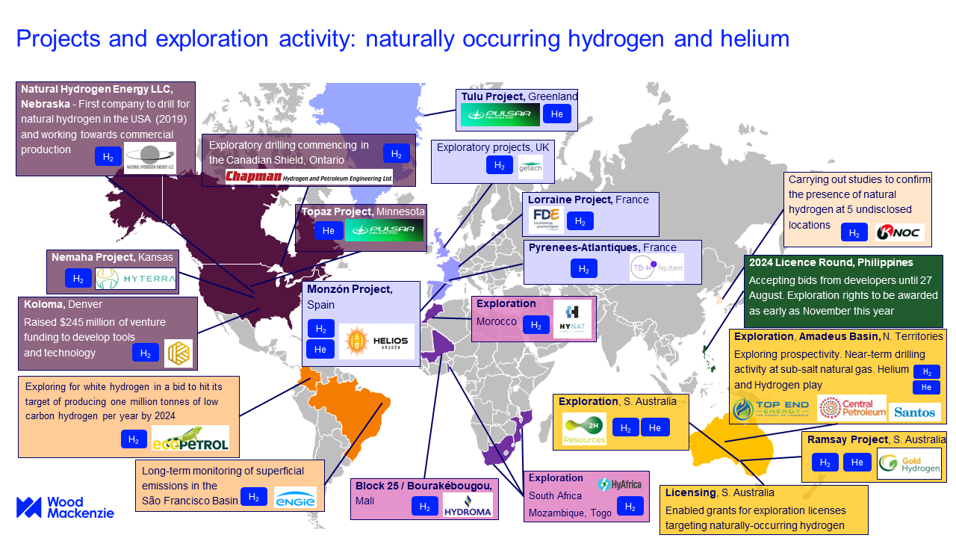
Image 17 Projects and exploration activity: naturally occurring hydrogen and helium. (Flowers., 2024).

7. Hydrogen transportation
Transportation depends on two factors, storage and means of transport. Several hydrogen storage models have been developed: compressing gas, cryogenic liquid, liquid organic hydrogen carriers (LOHCs), solid material hydrogen storage, and metal-organic framework hydrogen storage(MOF). Transport is possible through: pipelines, trains, trucks and ships.(Xie et al., 2024) These technologies were originally developed to export green/turquoise/blue/grey hydrogen but are also applicable to natural hydrogen.

7.1 storage methods
As hydrogen is a very diffuse gas, hydrogen transport requires an effective means of transport. Different methods of storage are used for different types of transport. This chapter will discuss various methods for the transportation of hydrogen. These methods are: compressed gas storage (7.1.1), liquid hydrogen storage/cryogenic liquid (7.1.2), Liquid Organic Hydrogen Carriers (LOHCs) (7.1.3), solid material hydrogen storage (7.1.4) and metal-organic framework hydrogen storage (MOF) (7.1.5).

7.1.1 compressed gas
Compressed gaseous hydrogen storage is the most commonly used method for hydrogen storage and is actively utilized in hydrogen fuel-cell vehicles. In tanks, hydrogen is stored at high pressure (up to 70 MPa). There are four types of tanks available with Type 5 being under development. For storage and transportation Type 3 and Type 4 are primarily used. Different types of tanks have various advantages and disadvantages in costs, weights, storage capabilities, and reactivity with hydrogen. Hydrogen tanks are typically composed of lightweight high-strength composite materials. (li et al., 2021) The cost of storage tanks varies depending on the type, with Type 4 tanks costing approximately €1,000–€1,800 per kilogram of hydrogen storage capacity. Compressed gas storage is relatively expensive for large-scale applications (Barthelemy et al., 2017).
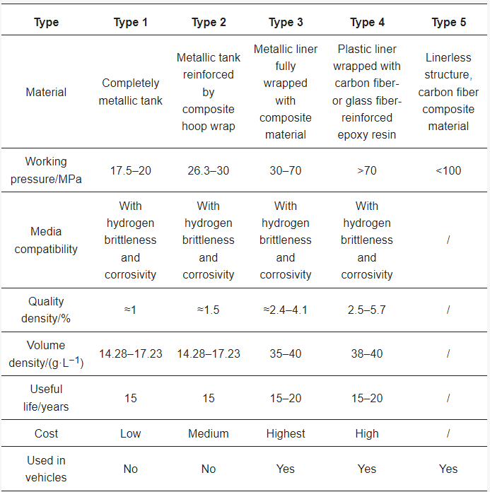
Image 18 The different types of gas storage. (Li et al., 2021).

7.1.2 Liquid hydrogen storage
Liquid hydrogen (LH₂) storage involves the cooling of hydrogen to its cryogenic temperatures at or below 33.2 K to increase the storage density. This method works on an energy-intensive liquefaction process but is efficient for long-distance. To minimize energy loss during storage, insulation is crucial, so vacuum insulation technology is used. An LH₂ storage tank comprises 3 parts, an inner vessel stores the hydrogen, an outer shell protects the inner vessel, and multi-layer insulation between the outer and inner vessels to minimize heat radiation. Materials like stainless steel and aluminum alloys are used for their low-temperature performance. (Xie et al., 2024) The cost of liquid hydrogen storage tanks ranges from €3,000–€6,000 per kilogram of hydrogen capacity, depending on insulation and materials. Liquefaction adds an additional cost of €1.00–€2.00 per kilogram of hydrogen (Barthelemy et al., 2017).
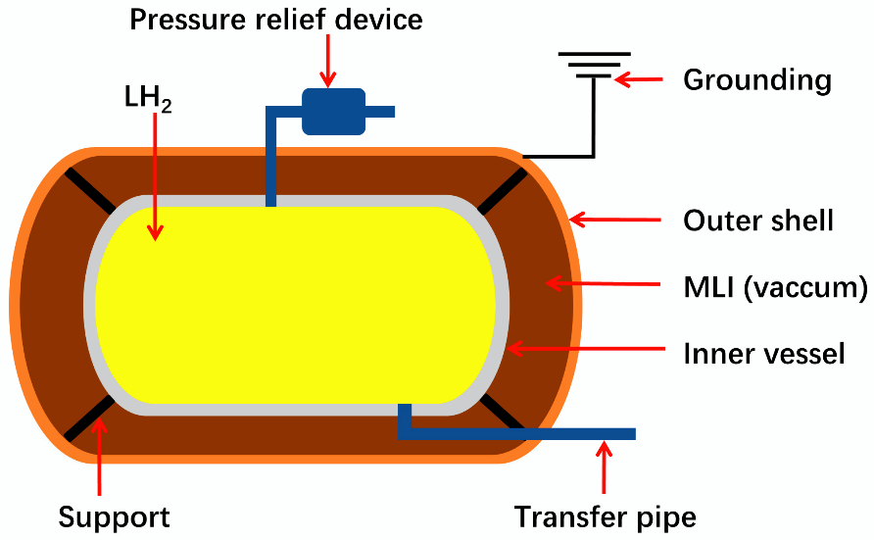
Image 19 Structure of a liquid hydrogen tank. (Xie et al., 2024).

7.1.3 LOHCs
Organic liquid hydrogen storage is based on the hydrogenation and dehydrogenation of hydrogen-lean molecules, such as Liquid Organic Hydrogen Carriers (LOHCs). This method avoids high-pressure or cryogenic storage but depends on chemical processing at both ends. The hydrogenation process adds hydrogen to the LOHC at elevated pressures and temperatures, while the dehydrogenation process releases hydrogen from the LOHC at high temperatures. (Xie et al., 2024) These processes add a cost of approximately €0.75–€1.50 per kilogram of hydrogen for storage and release, with initial carrier material costs of €20–€30 per kilogram (Barthelemy et al., 2017). LOHCs offer a flexible and scalable solution for hydrogen transport. Current research is focused primarily on improving the efficiency and developing advanced catalysts.

7.1.4 Solid material hydrogen storage
Solid material hydrogen storage includes materials such as magnesium hydride, sodium borohydride, and ammonia borane. These materials offer high hydrogen storage capacity at the cost of requiring high temperatures for hydrogen release, making them energy-intensive. (Xie et al., 2024)
Magnesium-based materials have a high gravimetric hydrogen storage capacity. Magnesium is common in the crust lowering the cost of material acquisition. This however comes at the cost of requiring temperatures exceeding 573 K for releasing the hydrogen from the materials. Current research focuses on improving the microstructure of these materials to enhance their hydrogen storage performance. Techniques such as equal-channel angular pressing (ECAP) and doping with elements such as titanium have shown promise in improving hydrogen diffusion and weakening Mg-H bonds.
Sodium borohydride (NaBH₄) is a solid hydrogen storage material known for its stability at room temperature and high theoretical hydrogen storage capacity (10.7 wt%). This makes it suitable for storage and transportation, although it also requires the application of high temperatures for hydrogen release.
Solid-state storage systems themselves range from €2,500–€5,000 per kilogram of hydrogen capacity, with additional operational costs of €0.50–€1.00 per kilogram for thermal energy requirements. (Barthelemy et al., 2017)

7.1.5 MOFs
Metal-organic frameworks (MOFs) are several types of porous materials that have hydrogen storage capabilities. MOFs consist of clusters that are coordinated with organic ligands, creating a highly porous structure with a large surface area. This structure allows MOFs to adsorb significant amounts of hydrogen at relatively low pressures and temperatures. (Shet et al., 2021) The advantage of MOFs is their high surface area, giving ample space for hydrogen absorption. MOFs can be easily tailored for optimal hydrogen storage capacity and absorption/desorption kinetics. Another advantage is the reversibility of MOFs; as absorption and desorption are reversible, MOFs are suitable for repeated use. MOF-based systems are estimated to cost €4,000–€8,000 per kilogram of hydrogen storage capacity, with ongoing research focused on reducing these costs through material optimization and scaling (Barthelemy et al., 2017).

Means of Transportation
Several methods are available for transporting hydrogen, each with different costs/benefits. Different forms of transportation have various advantages and disadvantages depending on the distance the hydrogen travels from the location where it is generated to the destination. This chapter explains pipeline transport (7.2.1), road transport (7.2.2), and ship transport (7.2.3).

7.2.1 Pipeline Transport
Pipelines are suitable for large-scale, long-distance hydrogen transport. They offer continuous and efficient delivery but require significant investment in infrastructure and safety measures to prevent leaks and handle hydrogen embrittlement. Dedicated hydrogen pipelines are designed to withstand the unique properties of hydrogen, including its small molecular size and tendency to cause embrittlement in metals. Mixing hydrogen with natural gas i pipelines currently in use is optional, although it may require modifications to handle the different properties of hydrogen. (Xie et al., 2024) Initial pipeline construction costs range from €1.00–€2.00 per kilometer per kilogram of hydrogen transported, depending on the terrain and material used. Upgrading natural gas pipelines currently in use for natural gas for hydrogen is a cheaper alternative, costing around €0.50–€1.00 per kilometer per kilogram. Pipes' Operating costs are typically low, at approximately €0.10–€0.20 per kilogram per 100 kilometers (Barthelemy et al., 2017).

7.2.2 Road transport
Hydrogen can be transported by road using high-pressure cylinders and cryogenic tanks. This method is useful for both shorter distances and smaller hydrogen quantities. Still, it involves challenges related to storage density and safety. High-pressure cylinders store hydrogen gas at pressures up to 700 bar. In contrast, cryogenic tanks store liquid hydrogen at temperatures below 20 K. Road transport offers flexibility and accessibility, making it ideal for distributing hydrogen to remote or decentralized locations. (Xie et al., 2024) The cost of transporting compressed hydrogen via truck is approximately €2.00–€3.50 per kilogram for distances up to 200 kilometers. For cryogenic liquid hydrogen, the price increases to €4.00–€6.00 per kilogram for the same distance, mainly due to additional cooling and insulation requirements (Barthelemy et al., 2017).

7.2.3 Ship transport
Seaborne transport involves shipping hydrogen in liquid hydrogen or hydrogen carriers. This method is efficient for long-distance transport but requires specialized storage methods to maintain cryogenic temperatures and ensure safety. Liquid hydrogen is transported in cryogenic tanks on ships. In contrast, standard chemical tankers can transport hydrogen in systems such as Liquid Organic Hydrogen Carriers (LOHCs). Seaborne transport is particularly useful for international hydrogen trade, as it can aid in the transport of large quantities of hydrogen over marine environments. (Xie et al., 2024) The cost of transporting liquid hydrogen by ship is estimated at €5.00–€8.00 per kilogram for distances over 1,000 kilometers. LOHC-based transport is slightly cheaper, having a cost of about €4.00–€6.00 per kilogram while having the advantage of not needing cryogenic infrastructure. (Barthelemy et al., 2017)

7.3 calculating the cost of transportation
The overall life cycle cost (LCC) of hydrogen transport is measured as an average value cost that is distributed evenly per kilometer (km):
$\text{Ca=Cp + Cc + Cs + Ct + Cd}$ equation 11
$LCC=\sum_{n=1}^{T}{(Ca+M*Ca)/{\left(1+r\right)}^{n}}$ equation 12
Here LCC is the cost of transport per kilometer along the whole lifecycle, Ca is the total annual cost, Cp is the sum of all costs, Cc is the compression process cost, Cs is the storage cost, Ct is the transportation cost, and Cd is the distribution terminal cost. M is the proportion of annual maintenance cost to total cost, T is the project's life cycle in years, and r is the discount rate, which calculates the present value of future costs (Xie et al., 2024).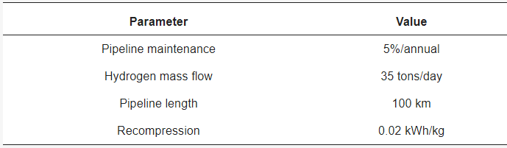
Image 20 Pipeline data (Xie et al., 2024).

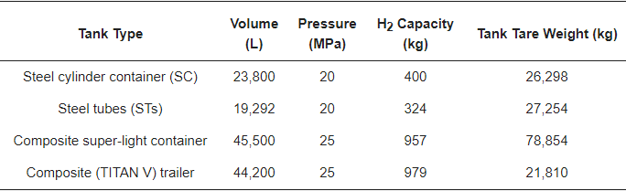
Image 21 Tank data (Xie et al., 2024)

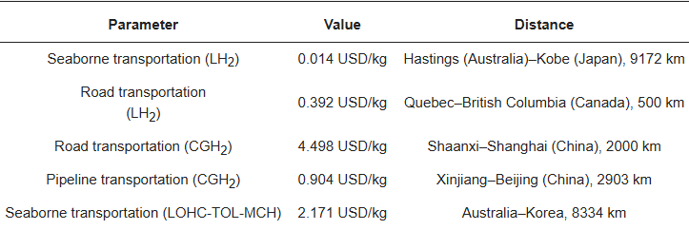
Image 22 Different transportation costs (Xie et al., 2024)

Results
The literature evaluation on white hydrogen has yielded significant insights into the geological formation, subsurface behavior, extraction methods, economic feasibility, and environmental impact of white hydrogen. These findings demonstrate the immense potential of natural hydrogen as a viable energy resource while highlighting the challenges that must be addressed to scale its production and utilization.
White hydrogen is produced through several geological processes, including serpentinization, radiolysis of water, mantle degassing, and rock weathering. Among these, serpentinization emerges as the most efficient process, capable of producing large quantities of hydrogen in localized areas. Experimental data and geophysical modeling confirm that serpentinization reactions, particularly in ultramafic rocks such as olivine-rich peridotites, yield high concentrations of hydrogen, especially under optimal temperature and pressure conditions. Radiolysis of water, while contributing significantly to hydrogen generation over geologic timescales, is more dispersed and challenging to target for economic extraction. Similarly, hydrogen degassing from the mantle, though abundant in specific tectonic settings, remains poorly understood due to the difficulty of direct measurements.
Geological analysis has shown that hydrogen migration and accumulation occur through faults, fractures, and porous rock formations, with impermeable rock layers acting as effective seals. Regions with active tectonics, ultramafic rock deposits, and specific surface features such as "fairy circles" and hydrogen seeps have been identified as promising exploration targets. Reservoir simulations indicate that hydrogen is likely to accumulate in subsurface traps similar to hydrocarbons, including structural traps like anticlines and fault barriers and stratigraphic traps involving variations in rock porosity and permeability. The findings in these behaviors showcase a strong resemblance to the principles of petroleum systems, offering a framework for hydrogen exploration.
Economic analysis reveals that white hydrogen has a significant cost advantage over other hydrogen sources. Current estimates suggest production costs as low as $1 per kilogram, making it competitive with gray and blue hydrogen and far more affordable than green hydrogen. The economic feasibility is further enhanced by the potential co-production of helium, a valuable byproduct in some hydrogen reservoirs. Advances in exploration and extraction technologies, such as seismic imaging, polymer casing, and hydrogen-specific sensors, have reduced costs and improved the efficiency of hydrogen recovery. These technological advancements also mitigate risks associated with extraction, such as hydrogen embrittlement and reservoir leakage.
White hydrogen may have a lower environmental impact than hydrogen made from fossil fuels, but this depends on the field and development method. Natural formation does not ensure that extraction is replenished at the same rate. Drilling, processing, compression and transport also require energy, and leakage can affect the overall climate benefit. Field monitoring and a life-cycle assessment are needed to evaluate these effects; the reservoir calculations in Chapter 5 do not quantify them.
The corrected tank and two DARTS models provide a sequence of numerical experiments on hydrogen extraction. Their purpose is to determine how the assumptions about storage, well flow, water and phase behavior affect predicted depletion. The models do not calculate geological hydrogen-generation rates or economic feasibility from first principles.
In the reconstructed tank example, interpreting the initial 0.6 km³ as gas at 1 bar and 298.14 K gives an initial mass of 48.76 million kg. Without replenishment, 31.52 million kg is produced over 100 years and pressure approaches the prescribed 160 bar well pressure. The reservoir therefore retains gas that cannot be produced under this control; it does not become empty after 30 years. Interpreting the same 0.6 km³ as gas-filled pore space gives a different inventory and depletion response, demonstrating the importance of volume reference conditions.
The first DARTS model resolves spatial pressure differences that are absent from the tank. After 365 days, the illustrative hydrogen case produces 12.26 million kg and has a mean pressure of 49.75 bar, compared with 56.85 bar for methane under the same well-pressure control. These cases have different initial gas masses, so their pressures and recovered fractions are more useful comparisons than mass production alone. The Bourakébougou model adds gas–water equilibrium and is discussed in Section 5.7. Conservation and refinement checks support the numerical calculations, while uncertainty in field properties limits their predictive interpretation.
Transportation and storage remain key challenges for scaling white hydrogen production and distribution, but significant progress has been made in addressing these issues, usually by using storage and transport methods that are used by other hydrogen production methods. Methods such as compressed gas storage, cryogenic liquids, liquid organic hydrogen carriers (LOHCs), and advanced materials like metal-organic frameworks (MOFs) offer viable hydrogen storage and delivery solutions. These technologies ensure the safe and efficient hydrogen transport from its source to industrial and energy markets, enabling its integration into existing energy infrastructure.
The results support further investigation of white hydrogen as a potential lower-carbon energy resource. Its commercial value depends on connected storage, well productivity, gas composition and the costs of extraction and delivery. The numerical examples clarify these physical questions, but do not establish reserves, commercial performance or sustainable replenishment. Geological measurements and production histories are needed to reduce those uncertainties.

Conclusions
Natural hydrogen, also known as white hydrogen, may contribute to lower-carbon energy supplies where suitable accumulations can be developed. Formation processes discussed in this report include serpentinization, radiolysis, mantle degassing and water–rock reactions. In serpentinization, reactions between water and iron-bearing minerals can generate hydrogen. The rate and persistence depend on mineral availability, temperature, water supply and reaction progress; generation alone does not establish that production can be sustained.
White hydrogen systems have parallels to petroleum systems, particularly regarding resource migration and trapping mechanisms. However, the source locations and geological setting differences provide unique challenges and opportunities for hydrogen extraction. While petroleum systems rely on hydrocarbons sourced within sedimentary basins, hydrogen systems often depend on basement rocks, requiring advanced exploration techniques. Migration pathways such as faults and fractures act as highways for hydrogen movement, and accumulation in porous rock layers or structural traps like anticlines and fault barriers further enhances its viability as an energy source.
The economic feasibility of white hydrogen extraction has been demonstrated, with costs estimated at approximately €1 per kilogram. This cost is competitive with gray and blue hydrogen and significantly lower than green hydrogen, which remains constrained by high electricity and equipment costs. Advances in exploration technologies, including seismic imaging, drilling techniques, and geophysical modeling, have improved the identification and characterization of hydrogen reservoirs, allowing for more efficient and cost-effective extraction. Moreover, the potential to co-extract helium from some hydrogen reservoirs creates another economic incentive, reducing the overall cost of white hydrogen production further.
Transportation and storage solutions play an important role in realizing the full potential of white hydrogen as an energy resource. Methods currently in use or under development, like compressed gas storage, liquid hydrogen storage, LOHCs, and MOFs, could aid in the scalability of hydrogen transportation to markets. Each storage method has unique advantages tailored to different transportation needs, from pipelines to shipping, enabling hydrogen to reach diverse industrial and energy applications.
Natural hydrogen may offer environmental advantages, but generation and accumulation do not by themselves ensure a sustainable extraction rate. The model results show that depletion depends on connected storage, production controls and any external supply. Establishing replenishment requires field measurements of pressure, cumulative production, fluid composition and inflow. Life-cycle impacts, leakage and surface processing also require separate evaluation.
For exploration and drilling, it is important to note the volatile behavior of hydrogen. This can be minimized by employing advanced monitoring systems and the use of hydrogen-resistant materials, such as polymer casings, to mitigate potential risks, ensuring safe and sustainable operations.
Despite these advantages, challenges remain. The accessibility of white hydrogen reservoirs depends on geological conditions, with active tectonic regions, ultramafic rock formations, and fault systems being the most promising areas for exploration. Additionally, the behavior of hydrogen in subsurface environments, influenced by factors like temperature, pressure, and interactions with other gases, requires careful modeling and analysis. Understanding these dynamics is critical to optimizing hydrogen recovery and ensuring economic viability.
Natural hydrogen could contribute to lower-carbon energy supplies where suitable accumulations can be developed. The corrected tank and DARTS models clarify the physical assumptions needed to assess such accumulations and provide reproducible tools for further research. Their numerical verification is not a field history match or proof of renewable production. Measured reservoir properties and production histories are needed before estimating recoverable reserves, sustainable rates or commercial performance.

Reference list:
- Ali, I., Imanova, G., Alharbi, O. M., Hameed, A. M., & Siddiqui, M. N. (2023). Recent updates in direct radiation water-splitting methods of hydrogen production. Journal of Umm Al-Qura University for Applied Sciences, 1-12.
- Arrouvel, C., & Prinzhofer, A. (2021). Genesis of natural hydrogen: new insights from thermodynamic simulations. International Journal of Hydrogen Energy, 46(36), 18780-18794.
- Athia, N., Pandey, M., Sen, M., & Saxena, S. (2024). Factors affecting the economy of green hydrogen production pathways for sustainable development and their challenges. Environmental Science and Pollution Research, 31, 44542-44574
- Ball, P. J., & Czado, K. (2022). Natural hydrogen: the new frontier. Geoscientist.
- Barbier, S., Huang, F., Andreani, M., Tao, R., Hao, J., Eleish, A., ... & Daniel, I. (2020). A review of H2, CH4, and hydrocarbon formation in experimental serpentinization using network analysis. Frontiers in Earth Science, 8, 209.
- Barthélémy, H., Weber, M., & Barbier, F. (2017). Hydrogen storage: Recent improvements and industrial perspectives. International Journal of Hydrogen Energy, 42(11), 7254-7262.
- BYJU’s. (2022, May 17). Properties Of Water - Physical &amp; Chemical Properties | Chemistry. BYJUS. https://byjus.com/chemistry/physical-and-chemical-properties-of-water/
- Bouquet, A., Glein, C. R., Wyrick, D., & Waite, J. H. (2017). Alternative energy: production of H2 by radiolysis of water in the rocky cores of icy bodies. The Astrophysical Journal Letters, 840(1), L8.
- Busch, P., Kendall, A., & Lipman, T. (2023). A systematic review of life cycle greenhouse gas intensity values for hydrogen production pathways. Renewable and Sustainable Energy Reviews, 184, 113588.
- Cheng, Y., Feng, Z., Guo, C., Chen, P., Tan, C., & Shi, H. (2022). Links of hydrogen sulfide content with fluid components and physical properties of carbonate gas reservoirs: A case study of the Right Bank of Amu Darya, Turkmenistan. Frontiers in Earth Science, 10.
- Dodangoda, C., Ranjith, P. G., & Haque, A. (2024). Unlocking the potential of underground hydrogen storage for clean energy solutions. Geomechanics and Geophysics for Geo-Energy and Geo-Resources, 10, 130
- Donzé, F.-V., Truche, L., Shekari Namin, P., Lefeuvre, N., & Bazarkina, E. F. (2020). Migration of natural hydrogen from deep-seated sources in the São Francisco Basin, Brazil. Geosciences, 10(9), 346
- Elin, Y., & Peter L, W. (2010). Prediction of hydrogen gas viscosity at high pressure and high temperature. 熱物性, 24(1), 21-27.
- Ellis, G. S. (2023). Understanding the potential for geologic hydrogen resources. Energy Resources Program, U.S. Geological Survey.
- Engineeringtoolbox. (2024a, April 8). Hydrogen - Thermophysical properties. https://www.engineeringtoolbox.com/hydrogen-d_1419.html
- Engineeringtoolbox. (2024b, April 8). Methane - Thermophysical properties. https://www.engineeringtoolbox.com/methane-d_1420.html
- Engineeringtoolbox. (2024c, April 8). Nitrogen - thermophysical properties. https://www.engineeringtoolbox.com/nitrogen-d_1421.html
- Engineeringtoolbox. (2024d, May 8). Carbon dioxide - Thermophysical Properties. https://www.engineeringtoolbox.com/CO2-carbon-dioxide-properties-d_2017.html
- Engineeringtoolbox. (2024e, May 8). Hydrogen sulfide - Thermophysical Properties. https://www.engineeringtoolbox.com/hydrogen-sulfide-H2S-properties-d_2034.html
- Flowers, S. (2024, July 25). Unlocking the potential of white hydrogen | Wood Mackenzie. Wood Mackenzie. https://www.woodmac.com/blogs/the-edge/unlocking-the-potential-white-hydrogen/
- Fu, Y., van Berk, W., & Schulz, H.-M. (2016). Hydrogen sulfide formation, fate, and behavior in anhydrite-sealed carbonate gas reservoirs: A three-dimensional reactive mass transport modeling approach. AAPG Bulletin, 100(5), 843-865.
- Geymond, U., Briolet, T., Combaudon, V., Sissmann, O., Martinez, I., Duttine, M., & Moretti, I. (2023). Reassessing the role of magnetite during natural hydrogen generation. Frontiers in Earth Science, 11, 1169356.
- Geymond, U., Ramanaidou, E., Lévy, D., Ouaya, A., & Moretti, I. (2022). Can weathering of banded iron formations generate natural hydrogen? Evidence from Australia, Brazil and South Africa. Minerals, 12(2), 163.
- Global Energy Monitor. (2024, September 5). Gas Pipelines Dashboard - Global Energy Monitor. https://globalenergymonitor.org/projects/global-gas-infrastructure-tracker/ggit-pipelines-dashboard/
- Green, A., Smith, B., & Taylor, C. (2021). Advanced monitoring systems in resource extraction. Journal of Industrial Technology, 45(3), 234-245.
- Huang, R., Sun, W., Ding, X., Zhao, Y., & Song, M. (2020). Effect of pressure on the kinetics of peridotite serpentinization. Physics and Chemistry of Minerals, 47, 1-14.
- ICF. (2024). Examining the Current and Future Economics of Hydrogen Energy
- International Energy Agency (IEA). (2021). The Future of Hydrogen. Retrieved from IEA.
- International Renewable Energy Agency (IRENA). (2020). Green Hydrogen: A Guide to Policy Making. Retrieved from IRENA.
- Irfan, M., Zhou, L., Bai, Y., Yuan, S., Liang, T. T., Liu, Y. F., ... & Mu, B. Z. (2019). Insights into the hydrogen generation from water-iron rock reactions at low temperature and the key limiting factors in the process. International Journal of Hydrogen Energy, 44(33), 18007-18018.
- Jackson, O., Lawrence, S. R., Hutchinson, I. P., Stocks, A. E., Barnicoat, A. C., & Powney, M. (2024). Natural hydrogen: sources, systems and exploration plays. Geoenergy, 2(1), geoenergy2024-002.
- Jones, D., & Brown, E. (2022). Drilling techniques and materials in hydrogen extraction. Energy Resources Journal, 39(2), 178-189.
- Klein, F., Bach, W., & McCollom, T. M. (2013). Compositional controls on hydrogen generation during serpentinization of ultramafic rocks. Lithos, 178, 55-69.Le Caër, S. (2011). Water radiolysis: influence of oxide surfaces on H2 production under ionizing radiation. Water, 3(1), 235-253.
- Leila, M., Radwan, A. A., Abdelwahhab, M. A., & Moretti, I. (2023). Natural hydrogen in different contexts: geological, cosmochemical, and biological. Frontiers in Earth Science, 11, 1296646.
- Lemke, K., Rubatto, D., & Hermann, J. (2024). A rapid transition from subduction to Barrovian metamorphism: geochronology of mafic–ultramafic relicts of oceanic crust in the Central Alps, Switzerland. Swiss Journal of Geosciences, 117(1), 15.
- Lemmon, E. W., Huber, M. L., & Leachman, J. W. (2008). Revised standardized equation for hydrogen gas densities for fuel consumption applications. Journal of Research of the National Institute of Standards and Technology, 113(6), 341–350. https://tsapps.nist.gov/publication/get_pdf.cfm?pub_id=832233
- Li, J.; Zhang, L.; Li, R.; Yang, X.; Zhang, T. High-pressure gaseous hydrogen storage vessels: Current status and prospects. Energy Storage Sci. Technol. 2021, 10, 1835.
- Lin, L. H., Hall, J., Lippmann‐Pipke, J., Ward, J. A., Sherwood Lollar, B., DeFlaun, M., ... & Onstott, T. C. (2005). Radiolytic H2 in continental crust: nuclear power for deep subsurface microbial communities. Geochemistry, Geophysics, Geosystems, 6(7).
- Liu, Z., Liu, Y., & Wang, Z. (2024). Comparative study of temperature and pressure variation patterns in hydrogen and natural gas storage in Salt Cavern. Applied Sciences, 14(19), 9005. https://doi.org/10.3390/app14199005
- Liu, Z., Perez-Gussinye, M., García-Pintado, J., Mezri, L., & Bach, W. (2023). Mantle serpentinization and associated hydrogen flux at North Atlantic magma-poor rifted margins. Geology, 51(3), 284-289.
- Lodhia, B. H., & Clark, S. R. (2022). Computation of vertical fluid mobility of CO 2, methane, hydrogen and hydrocarbons through sandstones and carbonates. Scientific Reports, 12(1), 10216.
- Lukose, L., Dutta, D., Rajkakati, M., Guha, A., & Bhowmik, S. K. (2023). The reflectance spectroscopy of ultramafic rocks from the Nagaland Ophiolite Complex, NE India: Convergence of spectroscopic and petrological analyses. Journal of Earth System Science, 132(3), 96.
- Lyell Collection. (2023). Greenstones as a source of hydrogen in cratonic sedimentary basins. Retrieved on January 10, 2025, from https://www.lyellcollection.org/doi/reader/10.1144/SP547-2023-39
- Matveev, K. I. (2024). Computational modeling of high-speed flow of two-phase hydrogen through a tube with abrupt expansion. Hydrogen, 5(1), 14-28.
- McCollom, T. M., & Bach, W. (2009). Thermodynamic constraints on hydrogen generation during serpentinization of ultramafic rocks. Geochimica et Cosmochimica Acta, 73(3), 856-875.
- McCollom, T. M., Klein, F., Moskowitz, B., Berquó, T. S., Bach, W., & Templeton, A. S. (2020). Hydrogen generation and iron partitioning during experimental serpentinization of an olivine–pyroxene mixture. Geochimica et Cosmochimica Acta, 282, 55-75.
- McCollom, T.M., Klein, F., and Rambo, M. 2022. Hydrogen generation from serpentinization of iron-rich olivine on Mars, icy moons, and other planetary bodies. Icarus, 372, 114754.
- McCollom, T. M., & Shock, E. L. (1998). Fluid‐rock interactions in the lower oceanic crust: Thermodynamic models of hydrothermal alteration. Journal of Geophysical Research: Solid Earth, 103(B1), 547-575.
- Merugu, R., Gothalwal, R., Girisham, S., & Reddy, S. M. (2021). Bacterial Hydrogen Production: Prospects and Challenges. In Bioenergy Research: Biomass Waste to Energy (pp. 195-229). Springer
- Mügler, C., Jean‐Baptiste, P., Perez, F., & Charlou, J. L. (2016). Modeling of hydrogen production by serpentinization in ultramafic‐hosted hydrothermal systems: application to the Rainbow field. Geofluids, 16(3), 476-489.
- Munro, R. (2017). Cap Rock. Encyclopedia of Engineering Geology.
- Nozaka, T. (2012). Natural hydrogen: A new frontier for sustainable energy. Energy Policy, 45, 1-5.
- Natural hydrogen: a geological curiosity or the primary energy source for a low-carbon future? (2021, January 7). https://www.renewablematter.eu/en/natural-hydrogen-a-geological-curiosity-or-the-primary-energy-source-for-a-low-carbon-future
- Parnell, J., & Blamey, N. (2017). Hydrogen from radiolysis of aqueous fluid inclusions during diagenesis. Minerals, 7(8), 130.
- Patonia, A., & Poudineh, R. (2022). Cost-competitive green hydrogen: how to lower the cost of electrolysers? (No. 47). OIES Paper: EL.
- Natural hydrogen: a potential clean energy source beneath our feet. (n.d.). Yale E360. https://e360.yale.edu/features/natural-geologic-hydrogen-climate-change
- Prinzhofer, A., Moretti, I., Françolin, J., Pacheco, C., d'Agostino, A., Werly, J., & Rupin, F. (2019). Natural hydrogen continuous emission from sedimentary basins: The example of a Brazilian H2-emitting structure. International Journal of Hydrogen Energy, 44(12), 5676-5685.
- PwC. (2024). Analysing the Future Cost of Green Hydrogen
- Ward, L. (2024, May 7). Hydrocarbon Column Heights – Part 1. Rose. https://www.roseassoc.com/hydrocarbon-column-heights-part-1/
- Energy Institute. (2024, March 20). The white gold rush: 40 companies now in pursuit of natural hydrogen. https://knowledge.energyinst.org/new-energy-world/article?id=138647
- Schlissel, D., Wamsted, D., Mattei, S., & Sanzillo, T. (2022). Costs of Blue Hydrogen Production Too High Without Fiscal Life Support. Institute for Energy Economics and Financial Analysis.
- Shet, S. P., Priya, S. S., Sudhakar, K., & Tahir, M. (2021). A review on current trends in potential use of metal-organic framework for hydrogen storage. International Journal of Hydrogen Energy, 46(21), 11782-11803.
- Smith, J. (2023). Seismic imaging in resource extraction. Geophysical Research Letters, 50(1), 112-120.
- Staff, C. (2023, November 14). White Hydrogen reserves discovered in France - Civilsdaily. CivilsDaily. https://www.civilsdaily.com/news/white-hydrogen-reserves-discovered-france/
- Statista. (2025, January 3). Number of gas pipelines globally 2024, by status. https://www.statista.com/statistics/1131315/gas-pipelines-by-status-worldwide/
- Steinthorsdottir, K., Dipple, G. M., Cutts, J. A., Turvey, C. C., Milidragovic, D., & Peacock, S. M. (2022). Formation and preservation of brucite and awaruite in serpentinized and tectonized mantle in central British Columbia: implications for carbon mineralization and nickel mining. Journal of Petrology, 63(11), egac100.
- Sunjay, S. (2024, July). Geologic hydrogen exploration in lithosphere. Researchgate
- Truche, L., Donzé, F. V., Goskolli, E., Muceku, B., Loisy, C., Monnin, C., ... & Cerepi, A. (2024). A deep reservoir for hydrogen drives intense degassing in the Bulqizë ophiolite. Science, 383(6683), 618-621.
- UNECE. (2024). Hydrogen reservoirs in ophiolites. Retrieved on January 10, 2025, from https://unece.org/sites/default/files/2024-04/Muceku%20-%20Hydrogen%20reservoirs%20in%20ophiolites.pdf
- Warr, O., Giunta, T., Ballentine, C. J., & Lollar, B. S. (2019). Mechanisms and rates of 4He, 40Ar, and H2 production and accumulation in fracture fluids in Precambrian Shield environments. Chemical Geology, 530, 119322.
- White, P., & Black, R. (2024). Environmental impacts of hydrogen and petroleum extraction. Sustainable Energy Review, 52(4), 301-315.
- White hydrogen: 5 of the most critical questions answered. (2024, September 10). World Economic Forum. https://www.weforum.org/stories/2024/08/white-hydrogen-5-critical-questions-answered/
- Xie, Z., Jin, Q., Su, G., & Lu, W. (2024). A Review of Hydrogen Storage and Transportation: Progresses and Challenges. Energies, 17(16), 4070.
- Zoheir, B., Holzheid, A., Diab, A., Ragab, A., Deshesh, F., & Abdelnasser, A. (2024). Recycling of Au during Serpentinization of Ultramafic Rocks: A Case Study from Neoproterozoic Forearc Ophiolites, Egypt. Minerals, 14(9), 916.
- Zgonnik, V. (2020). The occurrence and geoscience of natural hydrogen: A comprehensive review. Earth-Science Reviews, 203, 103140.
Khait, M., & Voskov, D. V. (2017). Operator-based linearization for general purpose reservoir simulation. Journal of Petroleum Science and Engineering, 157, 990–998. https://doi.org/10.1016/j.petrol.2017.08.009
Maiga, O., Deville, E., Laval, J., Prinzhofer, A., & Diallo, A. B. (2023). Characterization of the spontaneously recharging natural hydrogen reservoirs of Bourakebougou in Mali. Scientific Reports, 13, 11876. https://doi.org/10.1038/s41598-023-38977-y
National Institute of Standards and Technology. (n.d.). Thermophysical properties of gases used in the semiconductor industry: Hydrogen. https://www.nist.gov/pml/sensor-science/fluid-metrology/database-thermophysical-properties-gases-used-semiconductor-11
Prinzhofer, A., Cissé, C. S. T., & Diallo, A. B. (2018). Discovery of a large accumulation of natural hydrogen in Bourakebougou (Mali). International Journal of Hydrogen Energy, 43, 19315–19326. https://doi.org/10.1016/j.ijhydene.2018.08.193
Voskov, D. V. (2017). Operator-based linearization approach for modeling of multiphase multi-component flow in porous media. Journal of Computational Physics, 337, 275–288. https://doi.org/10.1016/j.jcp.2017.02.041
International Association for the Properties of Water and Steam. (2004). Guideline on the Henry’s constant and vapor-liquid distribution constant for gases in H₂O and D₂O at high temperatures. https://iapws.org/technical-guidance/release/HenGuide
Peng, D.-Y., & Robinson, D. B. (1976). A new two-constant equation of state. Industrial & Engineering Chemistry Fundamentals, 15(1), 59–64. https://doi.org/10.1021/i160057a011
Rezaei, A., Hassanpouryouzband, A., Molnar, I., Derikvand, Z., Haszeldine, R. S., & Edlmann, K. (2022). Relative permeability of hydrogen and aqueous brines in sandstones and carbonates at reservoir conditions. Geophysical Research Letters, 49, e2022GL099433. https://doi.org/10.1029/2022GL099433
Wiesenburg, D. A., & Guinasso, N. L. (1979). Equilibrium solubilities of methane, carbon monoxide, and hydrogen in water and sea water. Journal of Chemical & Engineering Data, 24, 356–360. https://doi.org/10.1021/je60083a006
Ziabakhsh-Ganji, Z., & Kooi, H. (2012). An equation of state for thermodynamic equilibrium of gas mixtures and brines to allow simulation of the effects of impurities in subsurface CO₂ storage. International Journal of Greenhouse Gas Control, 11, S21–S34. https://doi.org/10.1016/j.ijggc.2012.07.025

Appendix

Appendix 1 Reproducible model implementation
The corrected notebook is Tank_model.ipynb in the programming for tank model folder beside this report. The maintained solver, tests and scenario driver are stored in the white_hydrogen project. The notebook runs the same implementation; it is not a separate set of equations. The example below reconstructs the primary tank case. Appendix 2 contains the saved results.
Open the corrected Tank_model.ipynb
Open the reusable tank model
Open the first DARTS notebook
Use the existing darts-local notebook kernel, with Python 3.11 at /Users/sanderbertdacosta/.local/share/python-envs/darts-py311/bin/python. The project launcher configures the native Open-DARTS runtime. From the reservoir simulation project folder, the following commands reproduce the saved tank and first DARTS examples:
./run_darts.sh white_hydrogen/tank/run_tank.py
./run_darts.sh white_hydrogen/darts/run.py
./run_darts.sh white_hydrogen/darts/run.py --methane
For the minor reconstruction, one year is 365.25 days and the standard gas conditions are explicitly 298.14 K and 1 bar. The driver below uses the reusable solver from the project root:
import math
from white_hydrogen.tank.tank_model import (
HydrogenEOS, StandardConditions, TankConfig,
RadialWell, OperatingStage, simulate,
)
gas = HydrogenEOS()
standard = StandardConditions(298.14, 1.0)
rho_sc = gas.density_kg_m3(1.0, 298.14)
initial_mass = 0.6e9 * rho_sc
gas_volume = initial_mass / gas.density_kg_m3(500, 600)
bulk_volume = gas_volume / 0.20
radius = math.sqrt(bulk_volume / (5 * math.pi * 30))
config = TankConfig(gas_volume, 600, 500)
well = RadialWell(
permeability_m2=1e-15, thickness_m=30,
drainage_radius_m=radius, well_radius_m=0.1,
viscosity_pa_s=2.79e-5, well_count=5, skin=0,
)
stage = OperatingStage(
duration_days=100 * 365.25,
production_target_sm3_day=0.235e9 / 365.25,
bottomhole_pressure_bar=160,
source_sm3_day=0, radial_well=well,
)
result = simulate(config, [stage], eos=gas,
standard=standard)
print(result.summary())
Hydrogen density is obtained from Equations 5.2–5.3 with the coefficient table below. The solver integrates mass and four cumulative fluxes, computes pressure by bracketed density inversion, evaluates radial capacity using a 12-point Gauss–Legendre pressure integral, and limits production to the requested target. The integrated balance is checked before a result is accepted.
Table A1 Coefficients in the normal-hydrogen density correlation
i | ai | bi | ci
1 | 0.05888460 | 1.325 | 1
2 | −0.06136111 | 1.87 | 1
3 | −0.002650473 | 2.5 | 2
4 | 0.002731125 | 2.8 | 2
5 | 0.001802374 | 2.938 | 2.42
6 | −0.001150707 | 3.14 | 2.63
7 | 0.9588528 × 10⁻⁴ | 3.37 | 3
8 | −0.1109040 × 10⁻⁶ | 3.75 | 4
9 | 0.1264403 × 10⁻⁹ | 4 | 5

Saved CSV files carry units in their column names. Verification JSON records the input assumptions and numerical checks. The scripts reject inputs outside the property ranges rather than extrapolating them. The tank and DARTS standard-volume conventions differ; compare masses or convert to common reference conditions before comparing gas volumes.

Appendix 2 Model figures and numerical records
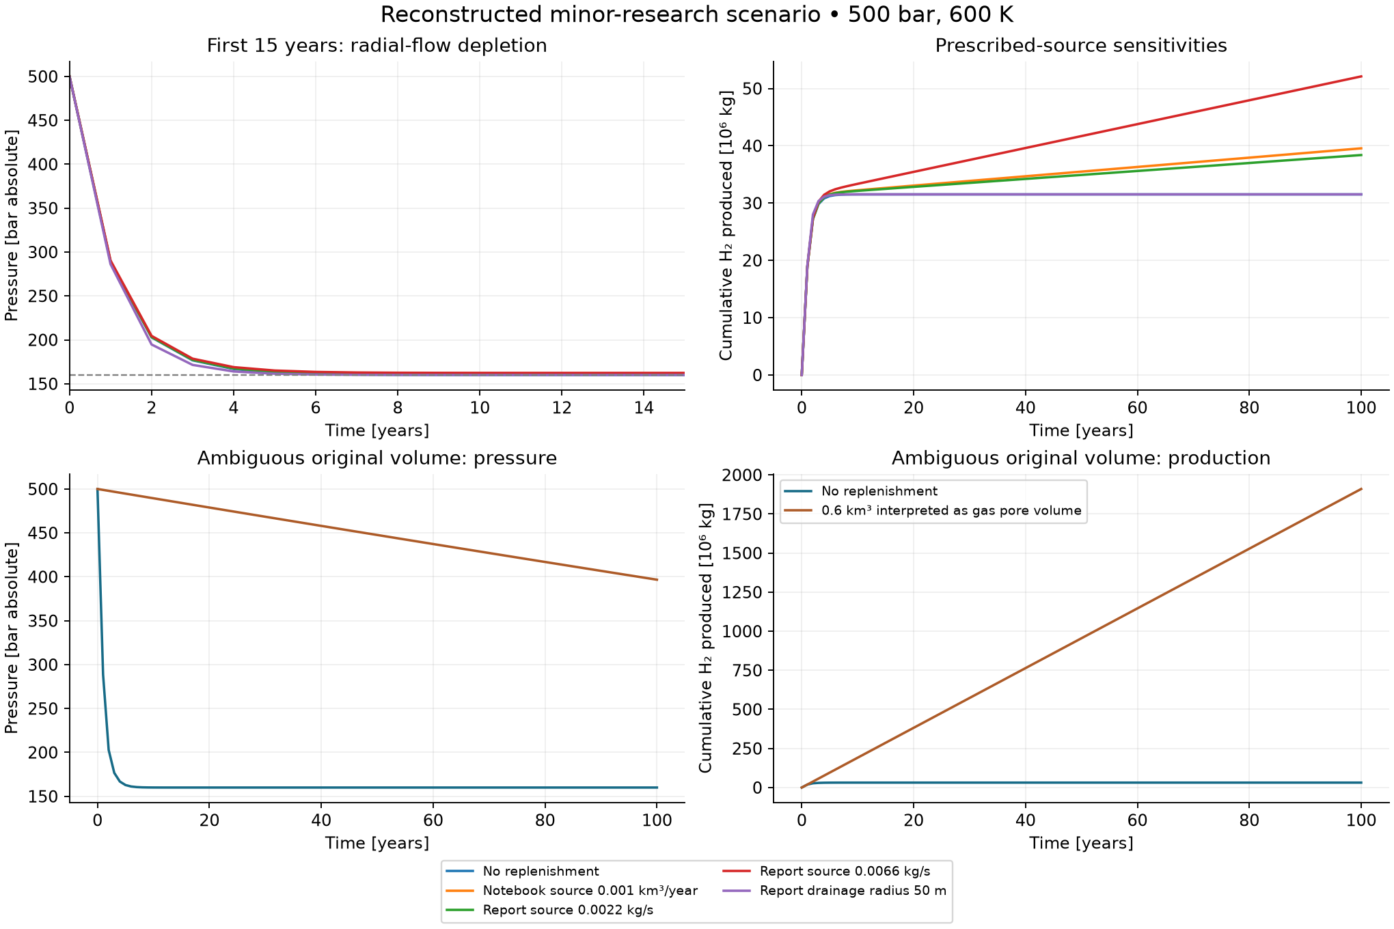
Figure A1 Reconstructed minor tank cases. Source rates and alternative storage interpretations are prescribed sensitivities. The pressure floor follows the specified 160 bar bottomhole-pressure control.
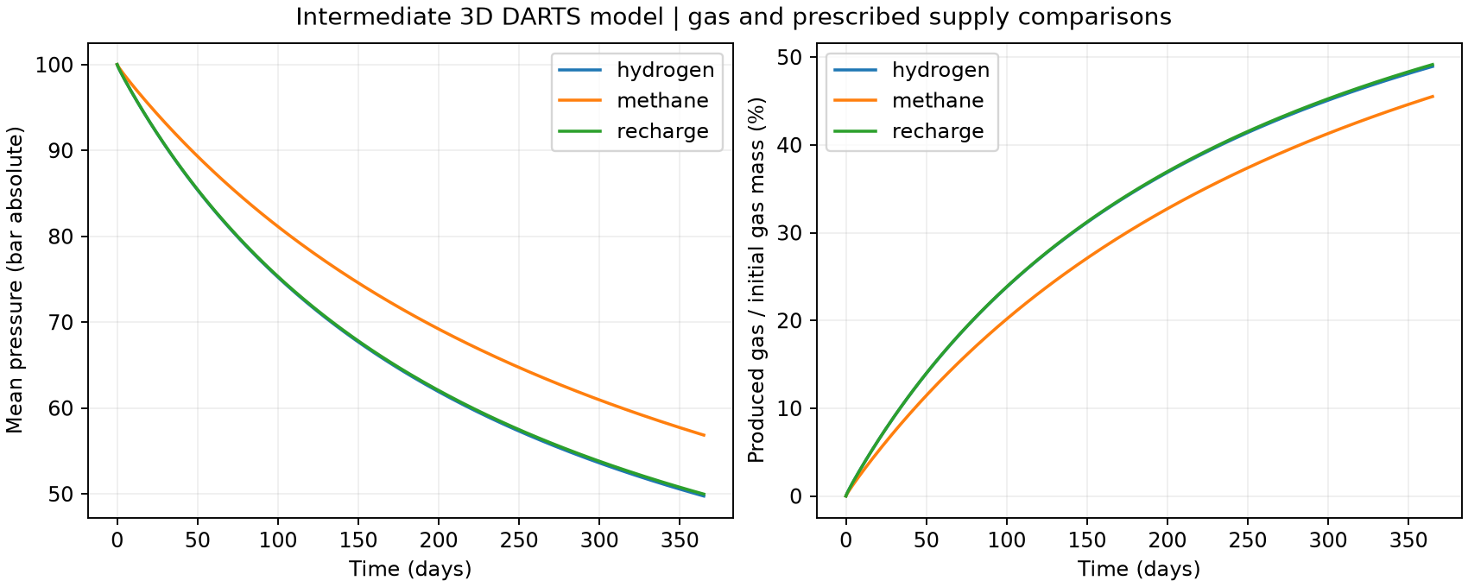
Figure A2 First DARTS model. Hydrogen depletion, hypothetical hydrogen supply and methane depletion under the same geometry and well-pressure control. All cases remain illustrative.
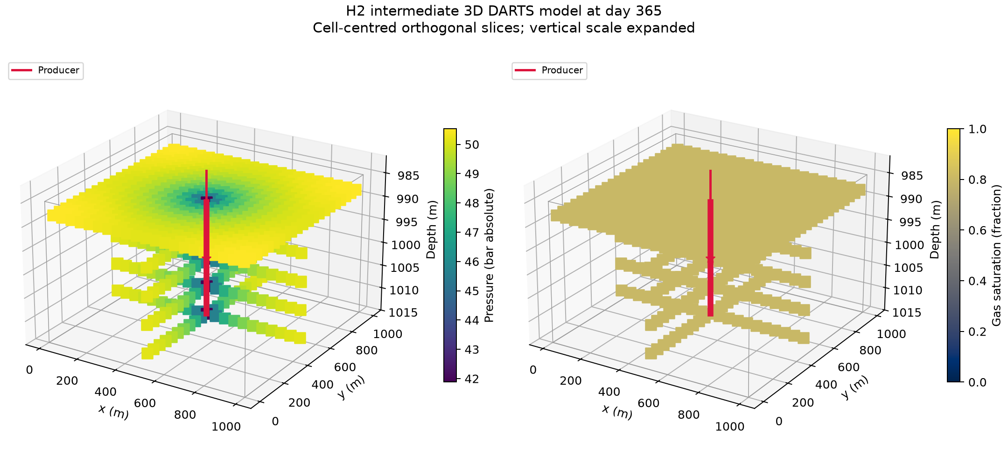
Figure A3 Three-dimensional first hydrogen DARTS model. The production well creates a spatial pressure gradient that the uniform-pressure tank cannot resolve.

Bourakébougou model files and figures
The Bourakébougou scripts, configuration, field-evidence record and fluid-property checks are stored in white_hydrogen/bourakebougou. The scenario JSON files separate assumed parameters from the observations used for context. Standard commands from the project root are:
./run_darts.sh white_hydrogen/bourakebougou/run.py
./run_darts.sh white_hydrogen/bourakebougou/validate.py
Open the Bourakébougou model script
Open the Bourakébougou notebook
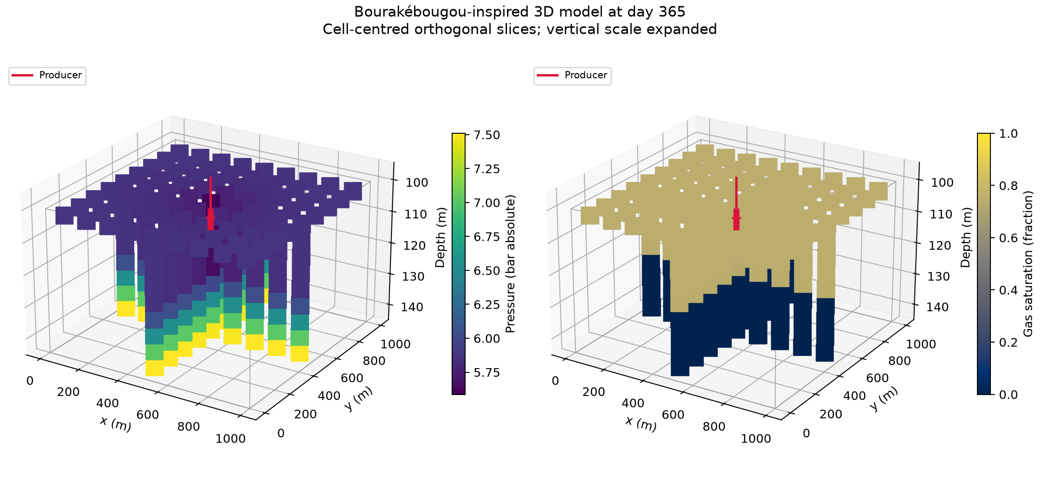
Figure A4 Three-dimensional Bourakébougou-inspired grid and gas distribution. The vertical scale is displayed for visibility; geometry and fluid distribution are scenario assumptions.
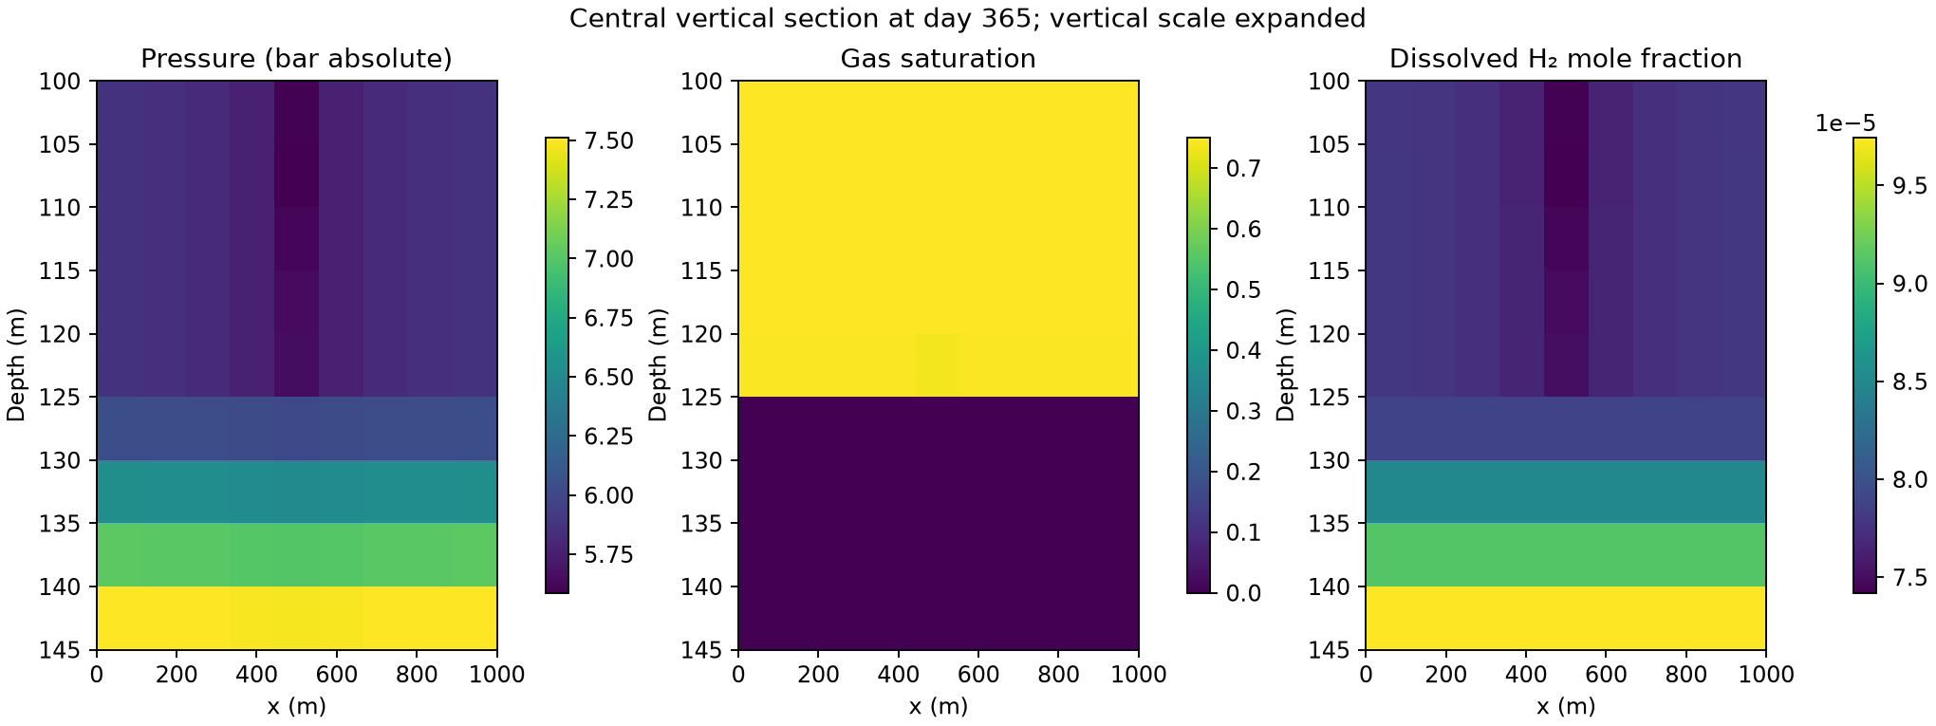
Figure A5 Vertical sections through the compositional model. Free and dissolved hydrogen are distinguished, with the assumed gas–water contact and depth-dependent pressure.
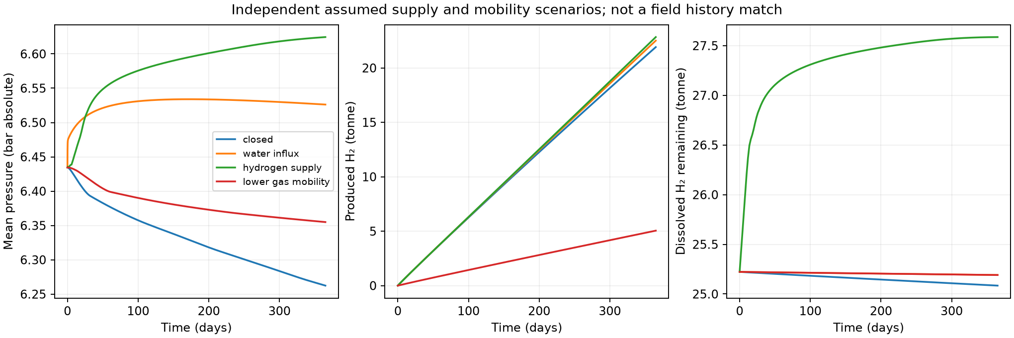
Figure A6 Comparison of closed depletion, prescribed hydrogen supply, water influx and gas-mobility sensitivity. These cases do not constitute field history matching.

